CORE GLOW
Natural Glowing Aggregate & Stones for Professionals, Homeowners & Designers
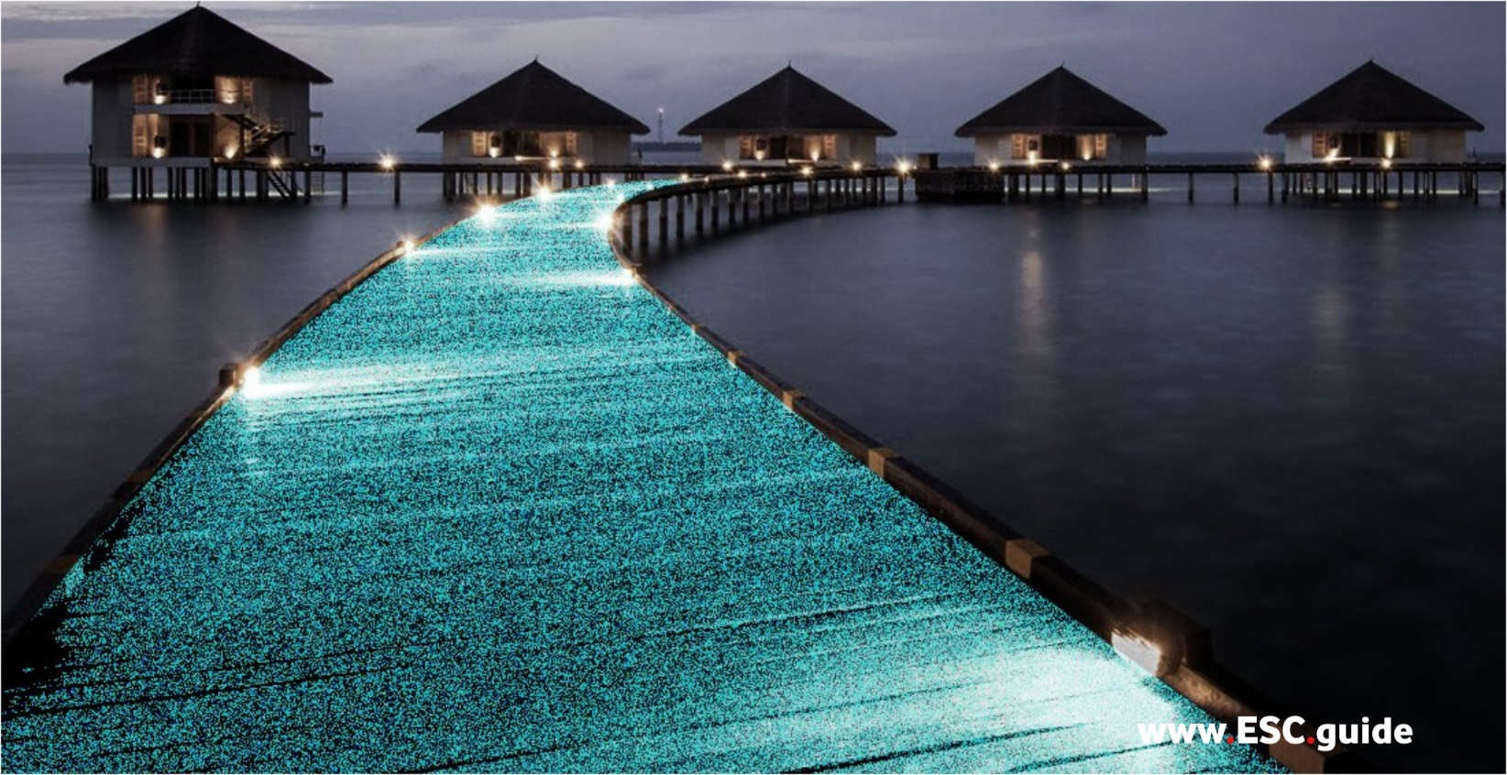
CORE Glow was founded in 2010 on the notion that we, as humans possess the ability to improve our environment through conscious choices. CORE Glow prides itself on creating sustainable products that enrich & protect the natural world. Our ongoing research and developments ensure that we create top quality products while providing the highest level of service. Our goal is to promote and educate the use of environmentally sustainable products that ensures a future where humans and nature can co-exist.
CORE Glow started in 2010 with only a handful of eco-friendly products, a small office, warehouse space, and a few friends. Today, CORE Glow is a growing company dedicated to creating and supplying unique and innovative products, for both private and public landscape settings, that are more eco-friendly and sustainable than traditional products.

More Information:
Web Link Presentation: | https://www.esc.guide/core-glow
Official Web Site: | https://www.coreglow.ca

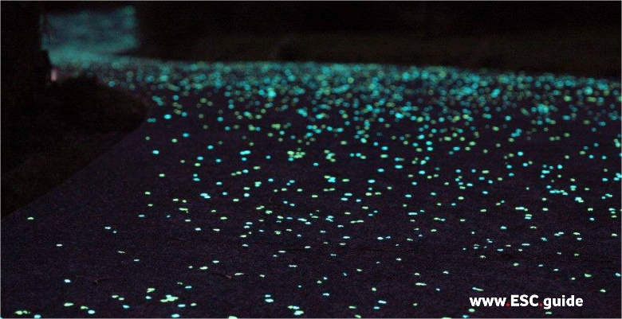 | 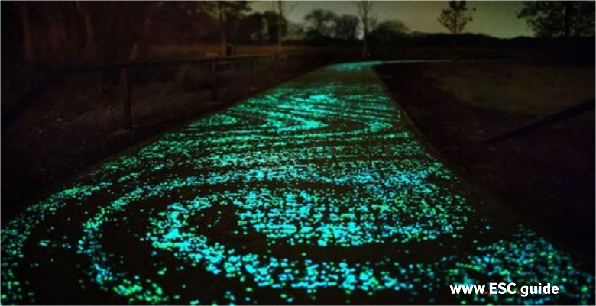
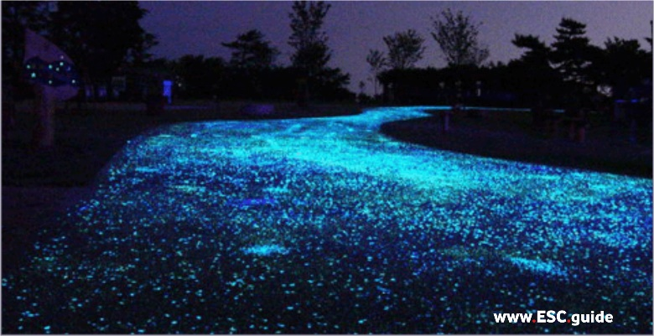 | 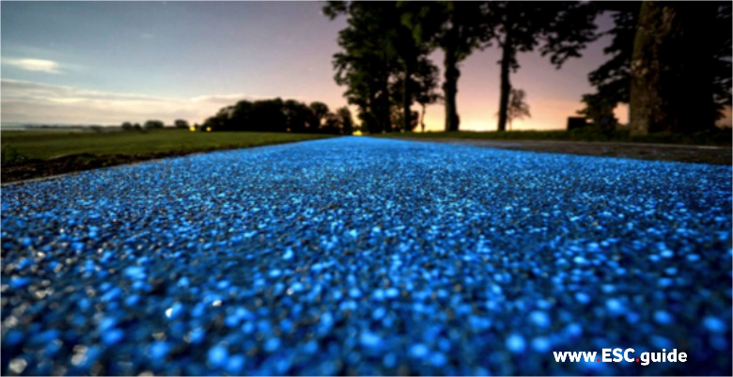
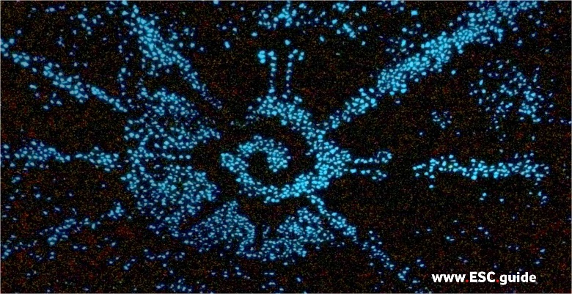 | 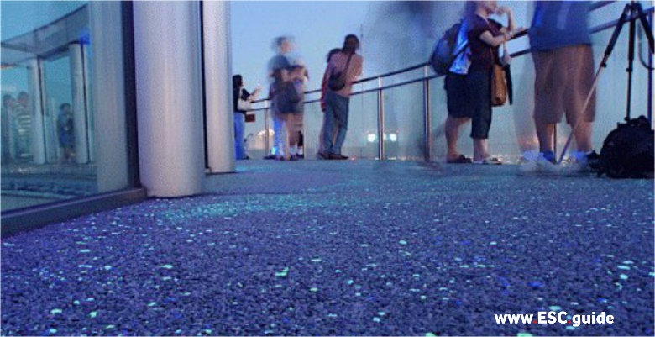
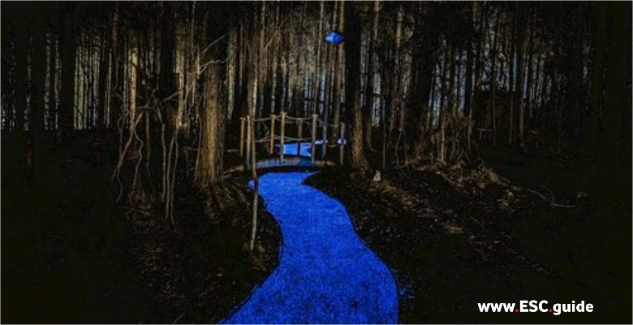 | 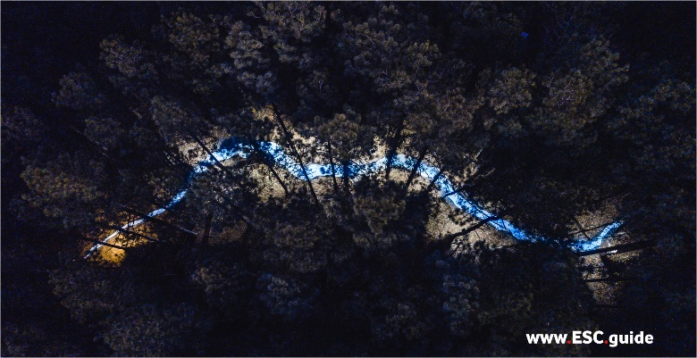
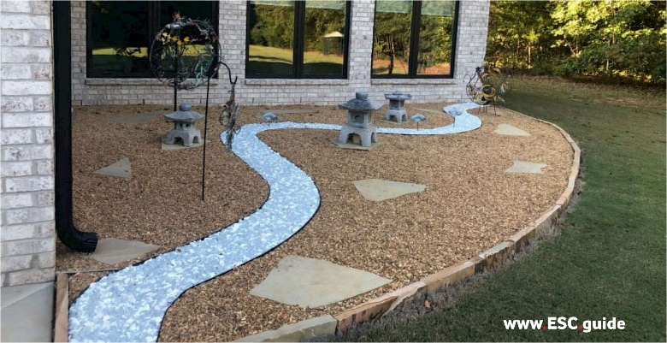 | 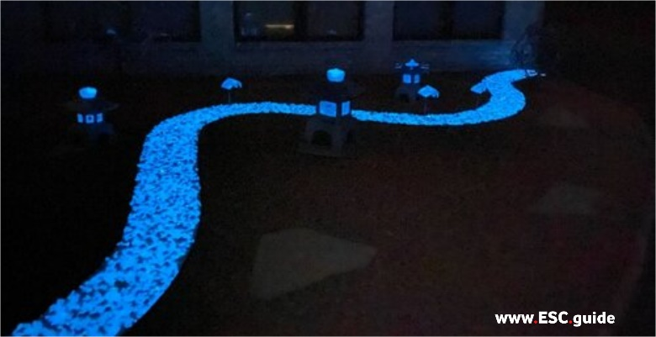
Specifications / Safety
We want our customers to enjoy their glow while ensuring their safety, so we encourage all buyers to read through the safety information before using their Core Glow products. Special note to those that are curious, no, you cannot eat CORE Glow!
*Note that CORE Glow powder especially requires Personal Safety Equipment when handling to prevent inhalation of the dust and contact with the eyes.*
See below for safety information, spec sheets on all of our products:
 | CORE GLOW Quantum GRADE aggregate  (Natural Stone): | Core Glow Commercial Grade aggregate  (Natural Stone): | Core Glow Stones (Plastic): | Core Glow Powder:
Recommended safety gear: | none required | none required | none required | gloves, respirator mask, goggles. Do not inhale or consume
MATERIAL | Strontium Aluminate, Europium Doped | Strontium Aluminate, Europium Doped | Synthetic resin (PS, PP, etc.) and luminescence | Luminescent powder
COLOR | Standard: Blue, Aqua & Green | Standard: Blue, Aqua & Green | Standard: White (Blue), Blue, Salmon pink, Light Green, Purple.  Custom colors: available | Standard: Blue, Aqua & Green
PEBBLE SIZE | X | X | Medium: 25mm x 15mm x 10mm, Large: 50mm x 40mm x 15mm | X
PEBBLE WEIGHT | X | X | Medium: 5g, Large: 15g | X
PEBBLE SHAPES | X | X | Minimum 3 random shapes for large and 5 for medium | X
SIZE | X | X | X | Fine Powder
SHAPES | X | X | X | N/A
AGGREGATE SIZE | 1-3mm, 3-8 mm,  8-15mm | 1-3mm, 3-8 mm,  8-15mm | X | X
AGGREGATE WEIGHT | Variable | Variable | X | X
AGGREGATE SHAPES | Chips: random | Chips: random | X | X
CHEMICAL RESISTANCE | Excellent | Excellent | Excellent | Avoid contact with acids
UV RESISTANCE | Excellent | Excellent | Excellent | Excellent
OIL/ALCOHOL RESISTANCE | X | X | X | Excellent
WATER RESISTANCE | Excellent can be used in outdoor and indoor applications | Excellent can be used in outdoor and indoor applications | Excellent can be used in underwater applications | N/A
LUMINESCENCE DURATION | Over 10 hours with 2 hours of daylight | Over 10 hours with 2 hours of daylight | Over 10 hours with 2 hours of daylight | Over 10 hours with 2 hours of daylight
LUMINESCENCE LIFE | Over 20 years | Over 20 years | Over 20 years | Over 20 years

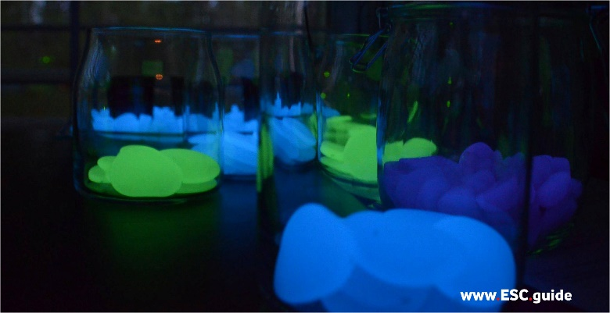 | 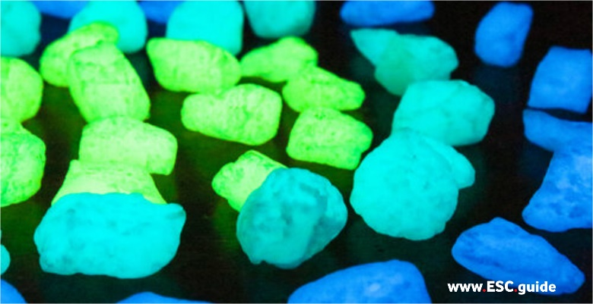
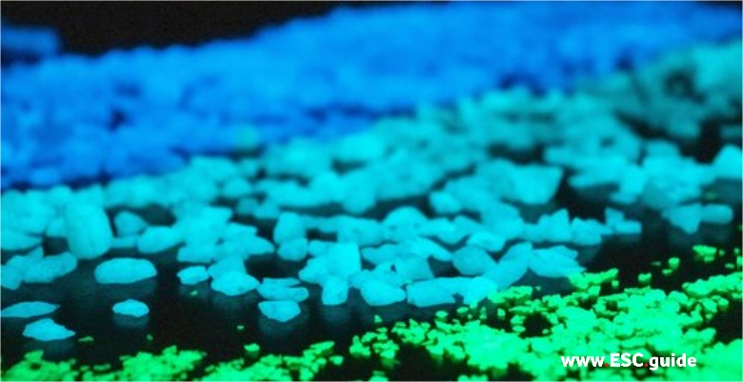 | 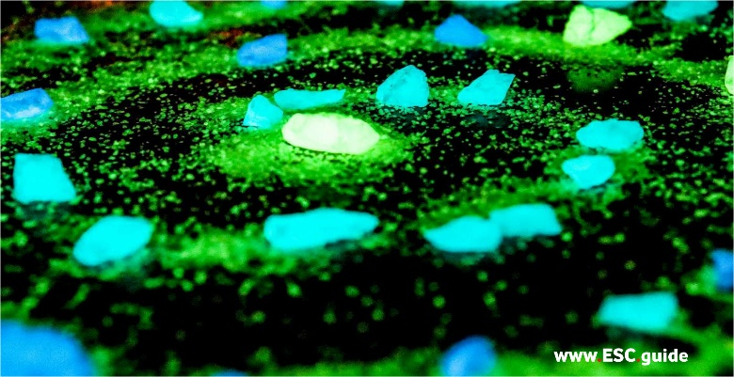
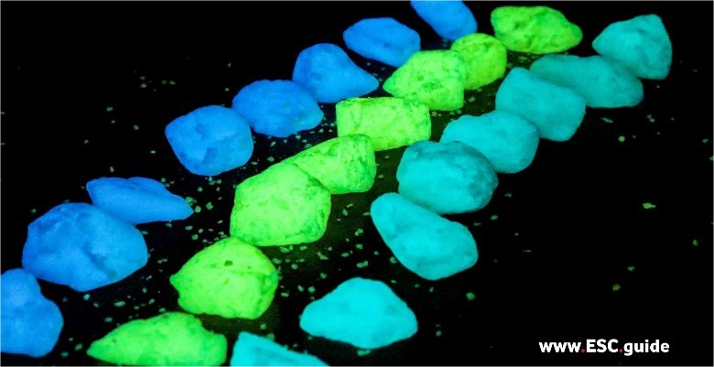 | 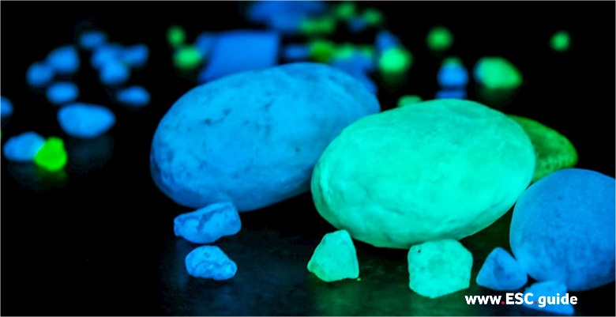
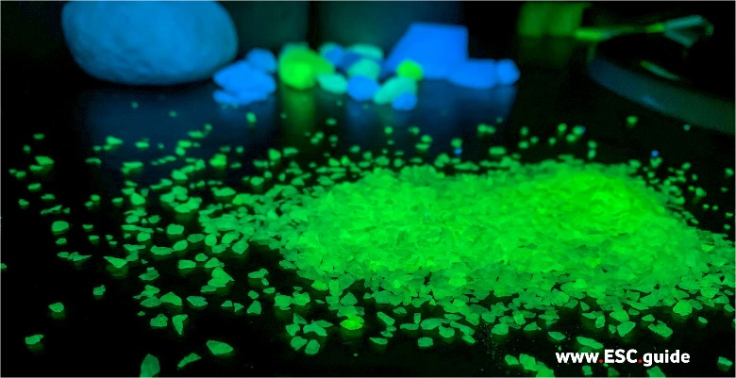 | 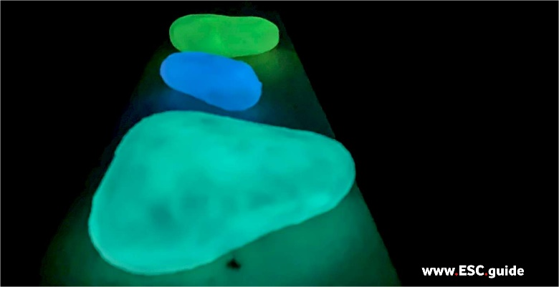
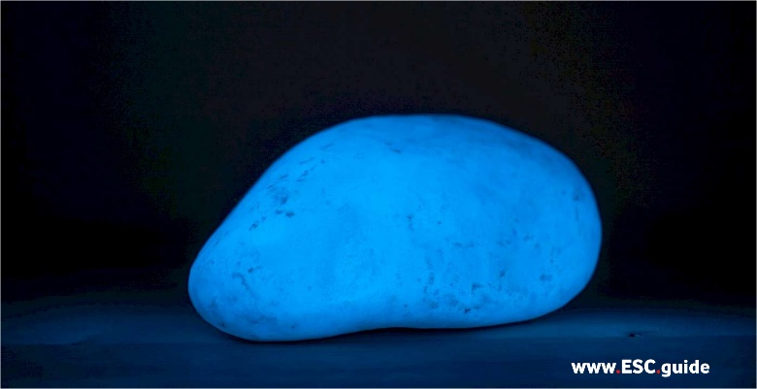 | 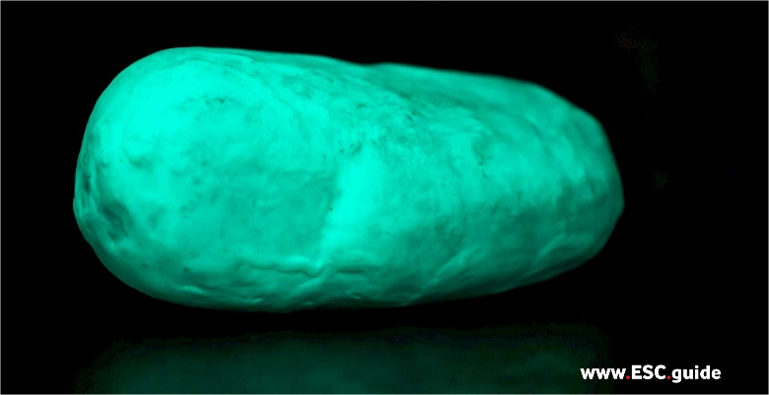
Earth-friendly Lighting
With CORE Glow electricity-free lighting you can create galaxy and bioluminescence-inspired glowing driveways, pathways, patios, gardens, countertops, flooring, and more.
CORE Glow photoluminescent aggregates are easy to install, charge within 20 minutes, and the luminescent material lasts for over 20 years.
No breaking, no fading, no electricity, just pure #sciencemagic.

Enjoy an evening glow with no power costs!
CORE Glow products are an eco-friendly lighting solution that requires no electricity. Use CORE Glow aggregate to illuminate your driveway, sidewalks and pathways with a soft welcoming glow at night. Ideal for enhancing lighting for edging, flower beds, house plants and more! The CORE Glow renewable light source emits zero carbon emissions, is affordable, and good for the planet!
Our CORE Glow luminescent products are engineered with proprietary luminescent material in mediums of glass, marble and synthetic resins. When exposed to daylight or a light source, the phosphorescent material becomes excited (wooo) and initially very radiant, then slowly dissipates as dawn arrives.

CORE GLOW Benefits
- Glow in the Dark, Reinvented: The new luminescent material in our CORE Glow products is a highly efficient microcrystal that enables light-storage with a long, bright afterglow, aka photoluminescence.
- Night Bright: The brightness and duration of the luminescent material we use are more than 10 times brighter than traditional ZnS (zinc sulfide) luminous material, that you would remember from glow in the dark stars!
- Energy-Efficient: With only 10-20 minutes of exposure to daylight or lamplight, the CORE Glow products can maintain it’s afterglow in the dark for about 10-12 hours.
- Waterproof: Expert engineering has enabled excellent water resistance compared to the common photoluminescent or afterglow pigments.
- Eco-Friendly, Non-Toxic & Safe: All CORE Glow products are non-radioactive, non-toxic and environmentally friendly. The photoluminescent material itself is biologically and chemically inert, and is REACH compliant.
- Energy Saving Solar Power: All CORE Glow products require no electricity and thus no wires, no power supply and no batteries. This saves natural resources and is another eco-friendly benefit.
- Colour Options: Available in 3 colours, green, aqua, and blue. Various day colours available.

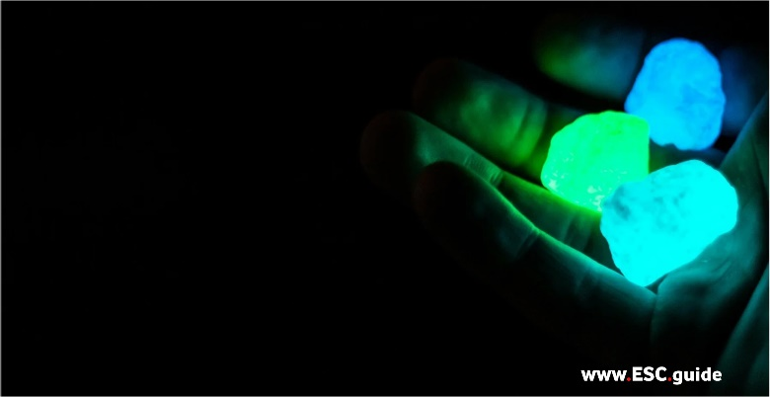 | 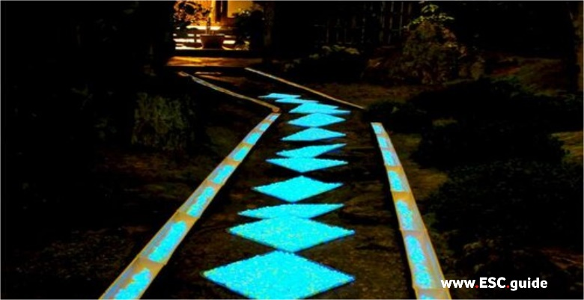
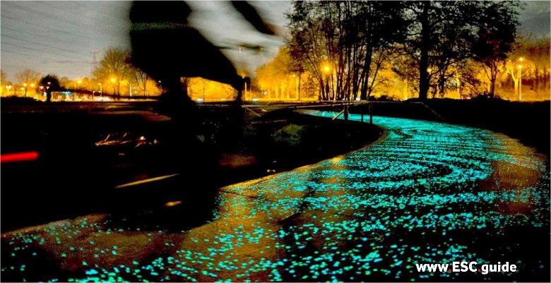 | 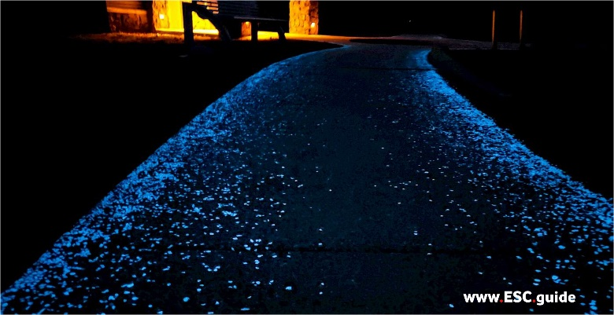
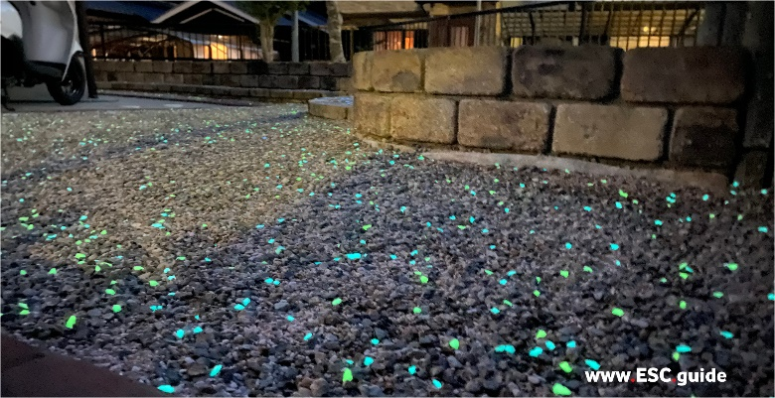 | 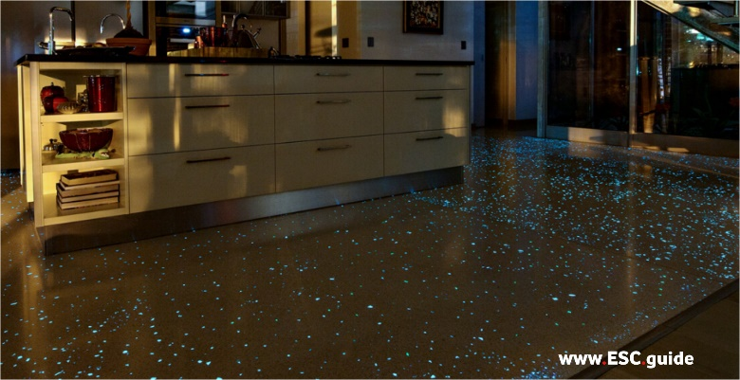
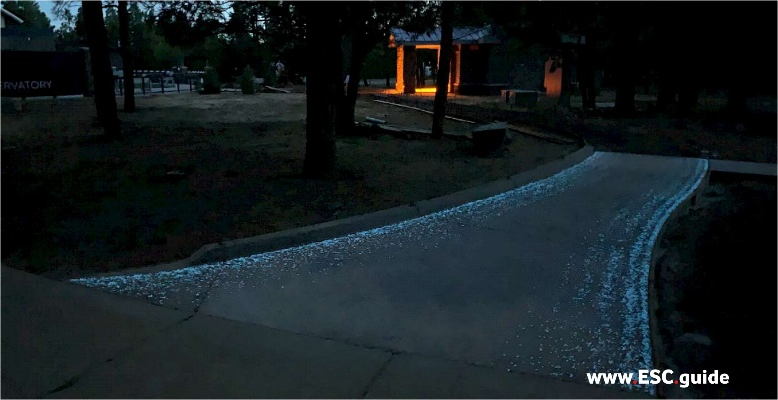 | 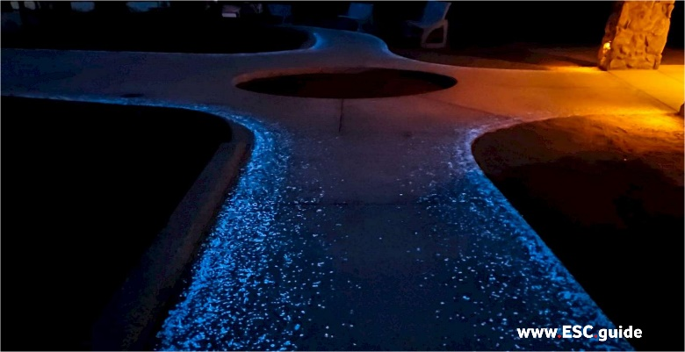
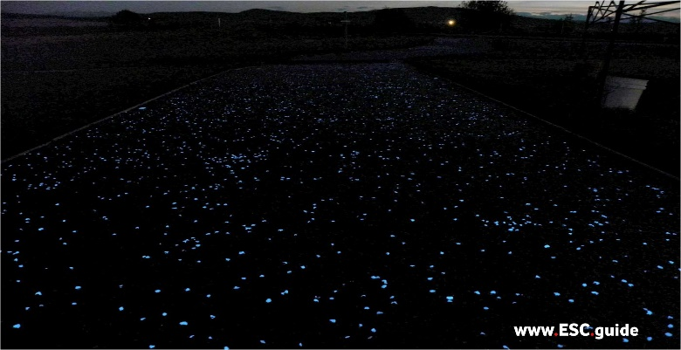 | 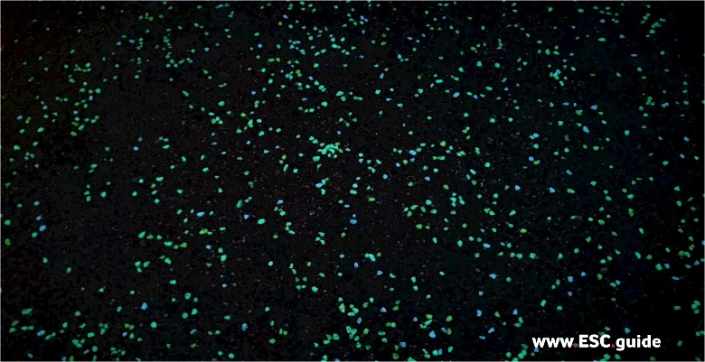
INDEX

A. PRODUCTS / PRICELIST
A.1. Quantum Grade Glow Aggregates (Brightest)
A.2. Commercial Grade Glow Aggregates
A.3. Quantum Boulders
A.4. Glow Stones

B. FAQ’s
B.1. General Questions about CORE Glow
B.2. Project Related Questions
B.3. Pricing Questions

C. PROJECT GUIDE
C.1. Instructables
C.2. Infographics

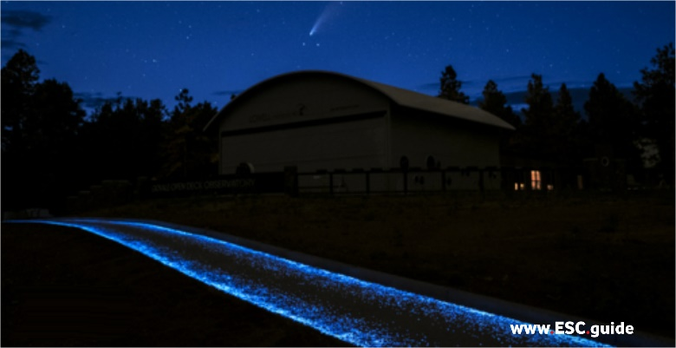 | 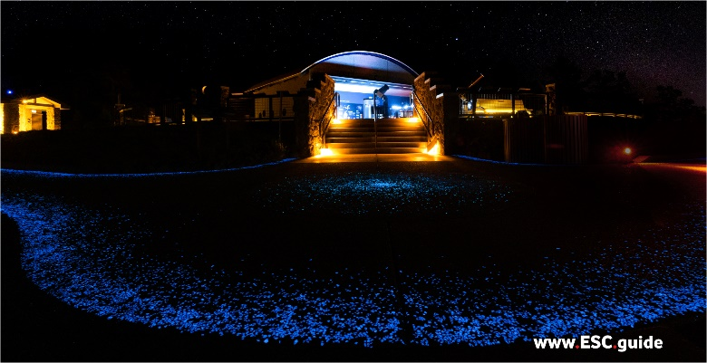
A. PRODUCTS / PRICELIST
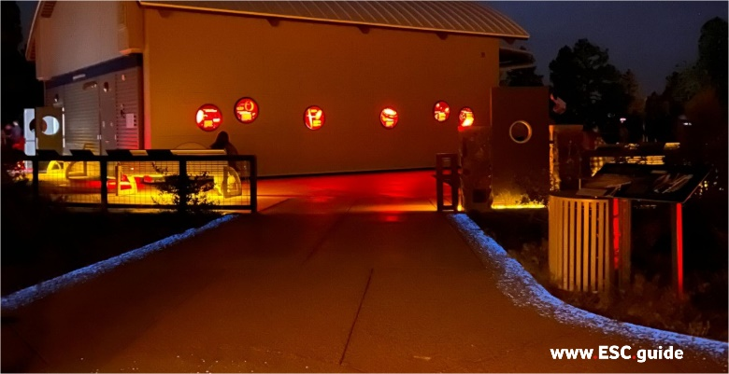 | 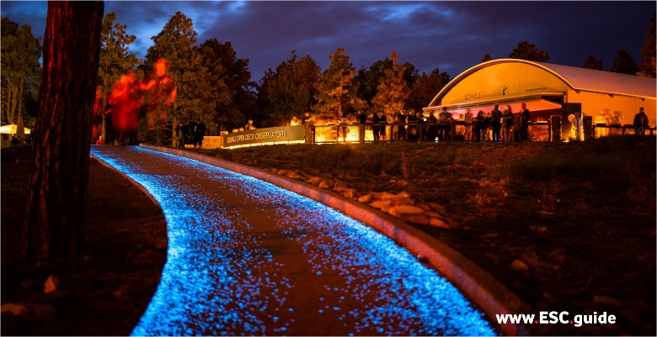
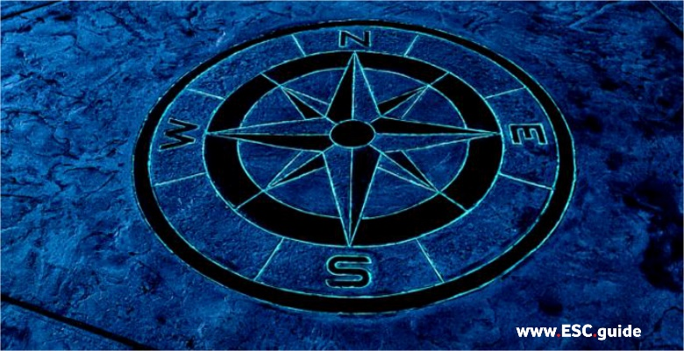 | 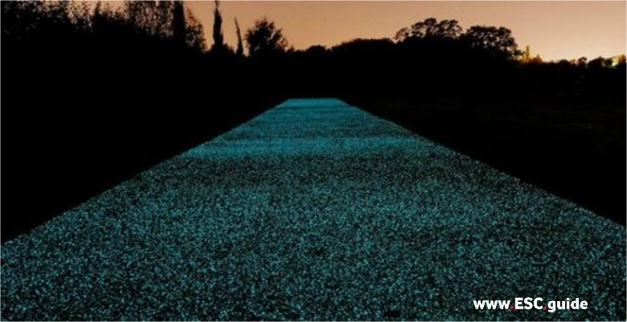
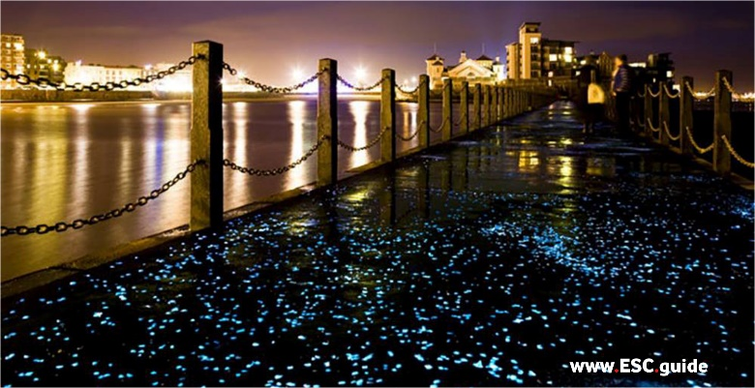 | 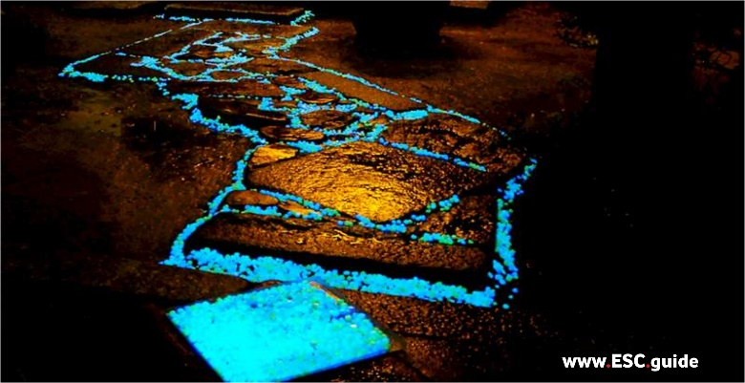

A.1. Quantum Grade Glow Aggregates (Brightest)
Our new Quantum product line has been formulated to maximize the brightness and longevity of the glow stones while ensuring no photoluminescent microcrystal is wasted. We increased the active concentration by 60% to create our new ultra-premium line, Quantum. The best glow at the best price.
1) | PURE CORE GLOW POWDER | €14,95
2) | 0.5-1MM QUANTUM GRADE AGGREGATE | €52,95
3) | 1-3MM QUANTUM GRADE AGGREGATE | €52,95
4) | 3-8MM QUANTUM GRADE AGGREGATE | €43,95
5) | 8-15MM QUANTUM GRADE AGGREGATE | €43,95
6) | 16-25MM QUANTUM GRADE AGGREGATE | €43,95
7) | CORE GLOW SAMPLE KIT | €23,95

A.2. Commercial Grade Glow Aggregates
Core Glow Commercial Grade Aggregates are the industry standard in photoluminescent lighting. Durable, rechargeable, and guaranteed awesome. Use in pathways, flooring, countertops, driveways, and more.
8) | 1-3MM COMMERCIAL GRADE AGGREGATE | €37,95
9) | 3-8MM COMMERCIAL GRADE AGGREGATE | €37,95
10) | 8-15MM COMMERCIAL GRADE AGGREGATE | €37,95
11) | SCIENCE OF GLOW GIFT BOX | €71,95

A.3. Quantum Boulders
12) | TINY BOULDERS | €43,95
13) | QUANTUM PACK | €22,95
14) | HALF CUT QUANTUM BOULDERS (3 PACK) FINAL PROTOTYPE! | €43,95
15) | HALF CUT QUANTUM BOULDER MIX PACK FINAL PROTOTYPE! | €47,95

A.4. Glow Stones
CORE Glow stones are the perfect addition for indoors and outdoor lighting and decoration. These stones are durable, all-weather and long-lasting composite stones. They are available in 1lb or 4lb bags and multiple color options. Please note these are NOT suitable to be embedded in concrete or asphalt as they are plastic.
16) | 1” STONES | €19,95
17) | 2” COBBLES | €22,95
18) | SCIENCE OF GLOW GIFT BOX | €71,95
19) | SCIENCE OF GLOW FOR KIDS | €39,95
20) | GLOW BEADS | €17,95

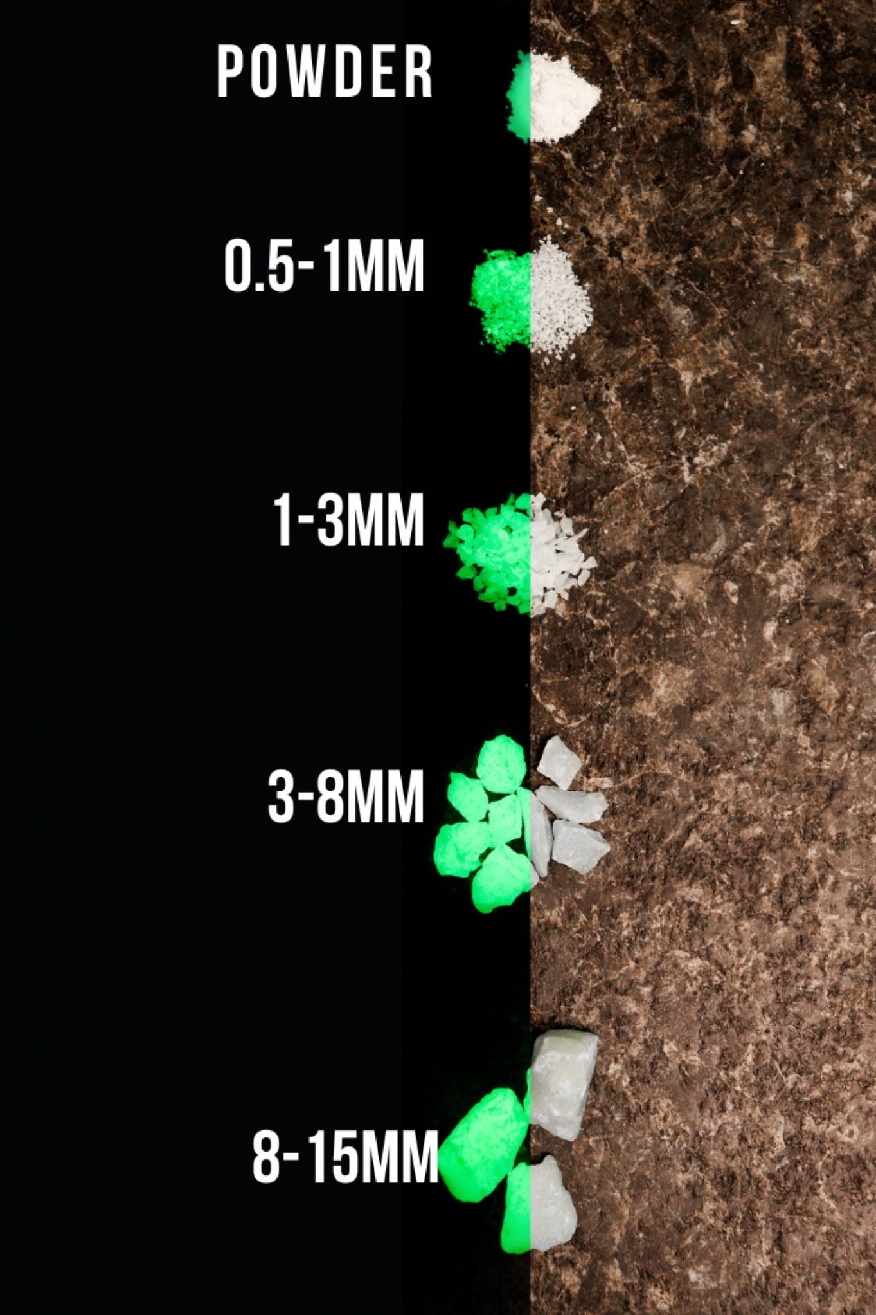
A.1.1) PURE CORE GLOW POWDER
€14,95 (1 oz) / €23,95 (4 oz) / €38,95 (8 oz) / €66,95 (16 oz)
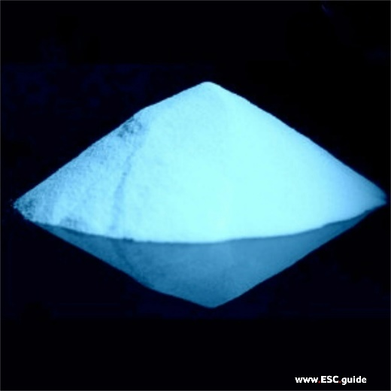 | 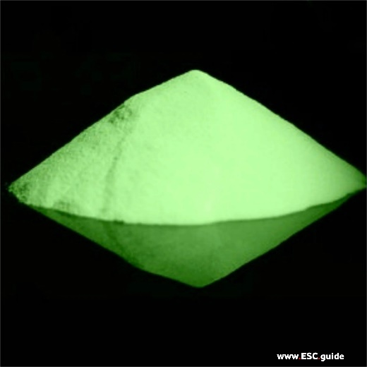 | 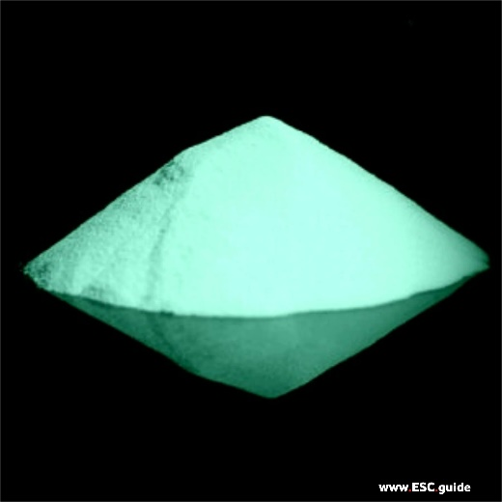
Blue | Green | Aqua
Color: Ethereal Blue – Soft and mysterious glow with 420nm peak wavelength. Great for use in otherworldly landscapes and relaxing ambiance. | Color: Hot Green – Brightest glow available at 520nm peak wavelength. Great for use in afety applications and eyecatching décor. | Color: Aqua Blaze – Energizing glow at 480nm peak wavelength. Great for use in high energy locations and eyecatching décor.

Use pure Core Glow Powder to make anything glow – mix with paint, resin, epoxy, moldings, and more to create your own glowing creations.
Core Glow Powder is intended for professional use. Consult our instruction sheet (C.1.2.) prior to use.
Particle size: ~25μmI
deal for fine mixes in clear resins, epoxies, and paints.

A.1.2) 0.5-1MM QUANTUM GRADE AGGREGATE
€52,95
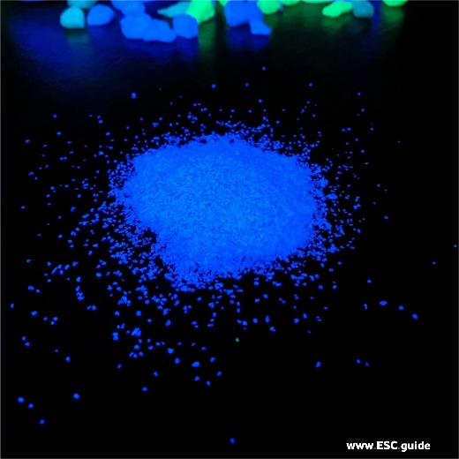 | 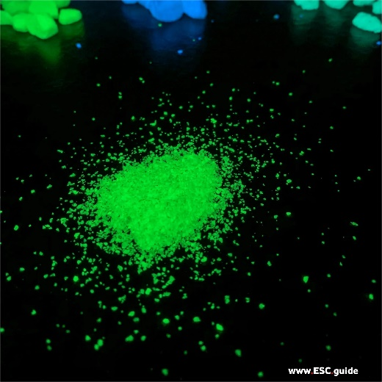 | 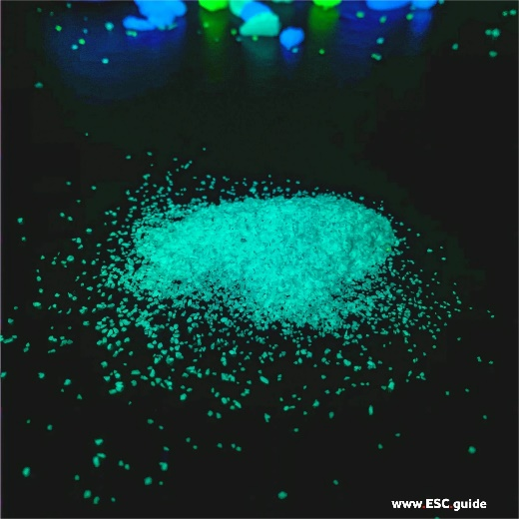
Blue 1lb | Green 1lb | Aqua 1lb
Ethereal Blue 0.5-1mm Quantum Glow:  Emission wavelength: 480nm  Optimum excitation wavelength: 200 - 450nm (standard and UV light)  Lux: 8 (0 hours), 2 (2-10 hours) | Green 0.5-1mm Quantum Glow:  Emission wavelength: 525nm  Optimum excitation wavelength: 200 - 450nm (standard and UV light)  Lux: 10 (0 hours), 2 (2-10 hours) | Aqua Blaze 0.5-1mm Quantum Glow:  Emission wavelength: 480nm  Optimum excitation wavelength: 200 - 450nm (standard and UV light)  Lux: 8 (0 hours), 2 (2-10 hours)

Our new Quantum product line has been formulated to maximize the brightness and longevity of the glow stones while ensuring no photoluminescent microcrystal is wasted. We increased the concentration by 60% to create our new ultra-premium line, Quantum, for the best glow at the best price.
Quantum is:
- 60% more powerful than our commercial grade glow stones
- Glow Duration: 12+ Hours
- Charge time: 10 mins (UV preferred)
- Lifespan: 20+ years

Environmental Accountability: Quantum is a highly durable product, designed for long-term usage. We are committed to continuously innovating to make Core Glow products longer-lasting, more durable, and brighter, in order to continuously improve our environmental impact. Thank you for joining us on this journey.
CORE Glow products are compliant with Dark Sky guidelines for light pollution reduction.

Note: Green Quantum is the brightest product we offer. The 525 nm green emission wavelength is closer to the center of the visible region, where spectral sensitivity of the human eye is at a maximum. This is why we recommend Hot Green for industrial and safety applications.

A.1.3.) 1-3MM QUANTUM GRADE AGGREGATE
€52,95
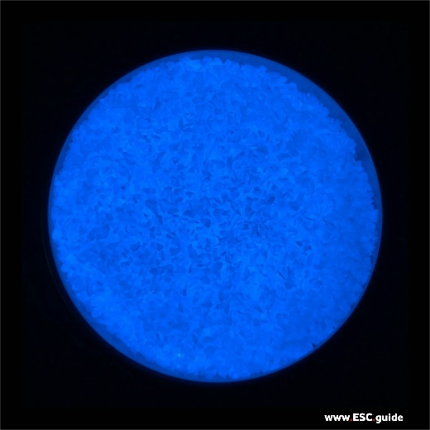 | 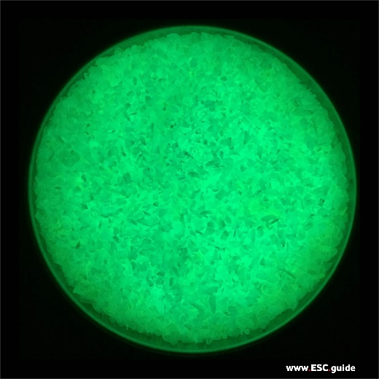 | 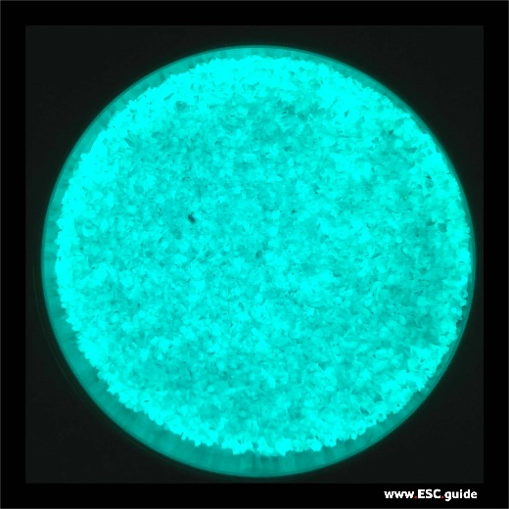
Blue 1lb | Green 1lb | Aqua 1lb
Blue 1-3mm Quantum Glow:  Emission wavelength: 420nm  Optimum excitation wavelength: 200 - 450nm (standard and UV light)  Lux: 8 (0 hours), 2 (2-10 hours) | Hot Green 1-3mm Quantum Glow:  Emission wavelength: 525nm  Optimum excitation wavelength: 200 - 450nm (standard and UV light)  Lux: 10 (0 hours), 2 (2-10 hours) | Aqua Blaze 1-3mm Quantum Glow: Emission wavelength: 480nm  Optimum excitation wavelength: 200 - 450nm (standard and UV light)  Lux: 8 (0 hours), 2 (2-10 hours)
Our new Quantum product line has been formulated to maximize the brightness and longevity of the glow stones while ensuring no photoluminescent microcrystal is wasted. We locked in at 60% additional pure glow powder for our new ultra-premium line, Quantum, for the best glow for the best value.
Quantum is:
- 60% more powerful than our commercial grade glow aggregates
- Glow Duration: 12+ Hours
- Charge time: 10 mins (UV preferred)
- Lifespan: 20+ years
Environmental Accountability: Quantum is a highly durable product, designed for long-term usage. We are committed to continuously innovating to make Core Glow products longer-lasting, more durable, and brighter, in order to continuously improve our environmental impact. Thank you for joining us on this journey.
Core Glow products are compliant with Dark Sky guidelines for light pollution reduction.

Note: Green Quantum is the brightest product we offer. The 525 nm green emission wavelength is closer to the center of the visible region, where spectral sensitivity of the human eye is at a maximum. This is why we recommend Hot Green for industrial and safety applications.

Coverage Guide
Based on 1 lb of Core Glow Commercial Grade Marble, 1 - 3 mm stone
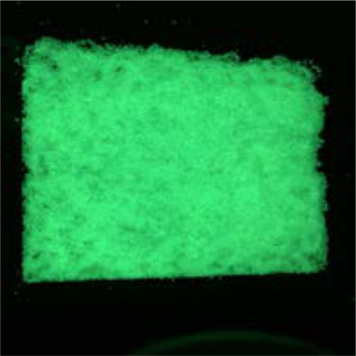 | 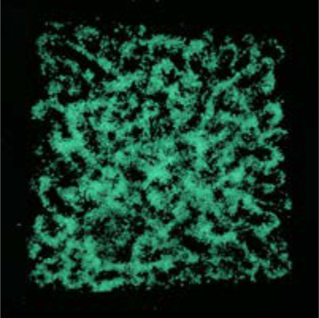 | 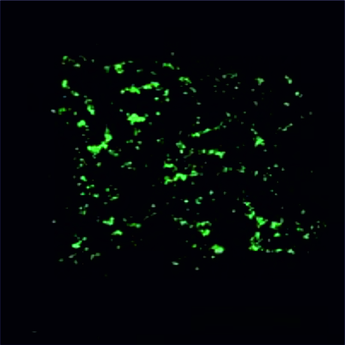
FULL  1 lb covers 2 sq.ft | MEDIUM  1 lb covers 16 sq.ft | EXTRA-LIGHT  1 lb covers 128 sq.ft
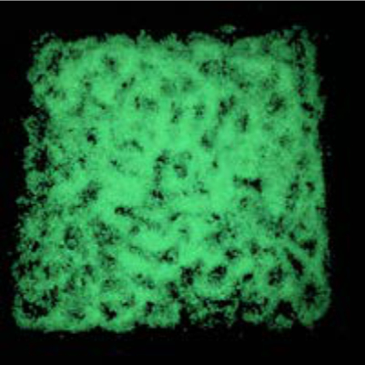 | 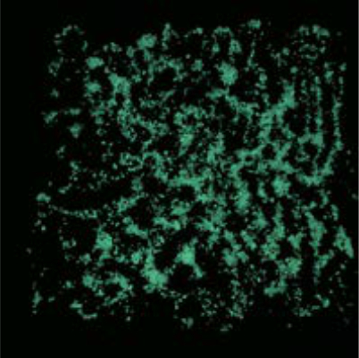
HEAVY  1 lb covers 4 sq.ft | MEDIUM-LIGHT  1 lb covers 32 sq.ft
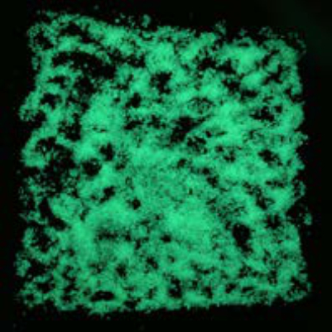 | 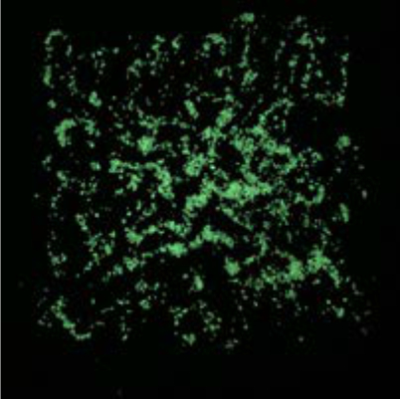
MED/HEAVY  1 lb covers 8 sq.ft | LIGHT  1 lb covers 64 sq.ft
A.1.4) 3-8MM QUANTUM GRADE AGGREGATE
€42,95
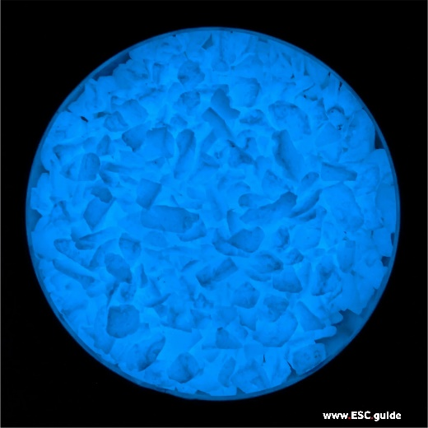 | 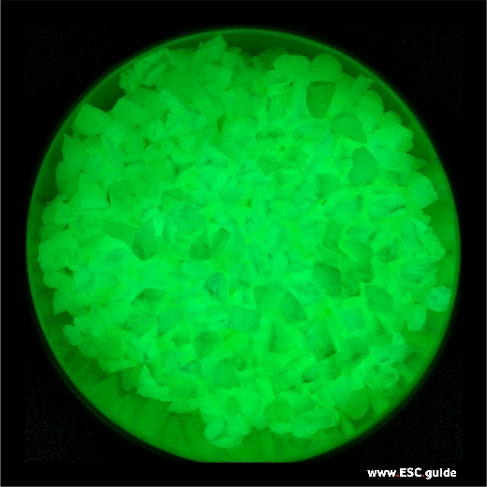 | 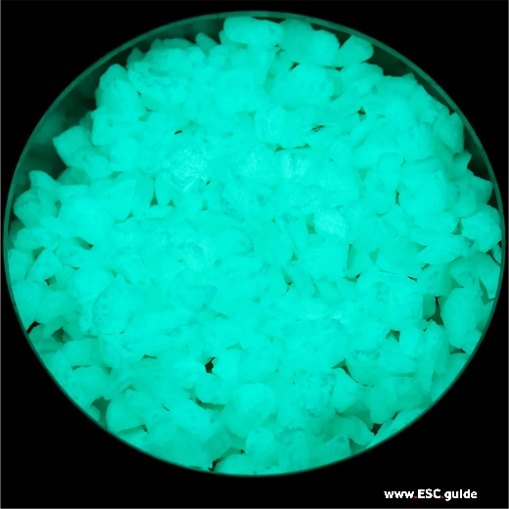
Blue 1lb | Green 1lb | Aqua 1lb
Ethereal Blue 3-8mm Quantum Glow:  Emission wavelength: 420nm  Optimum excitation wavelength: 200 - 450nm (standard and UV light)  Lux: 8 (0 hours), 2 (2-10 hours) | Hot Green 3-8mm Quantum Glow:  Emission wavelength: 520nm  Optimum excitation wavelength: 200 - 450nm (standard and UV light)  Lux: 10 (0 hours), 2 (2-10 hours) | Aqua Blaze 3-8mm Quantum Glow:  Emission wavelength: 480nm  Optimum excitation wavelength: 200 - 450nm (standard and UV light)  Lux: 8 (0 hours), 2 (2-10 hours)

Our new Quantum product line has been formulated to maximize the brightness and longevity of the glow stones while ensuring no photoluminescent microcrystal is wasted. We increased our glow powder by 60% to create our new ultra-premium line, Quantum, for the best glow at the best price.
Quantum is:
- 60% more powerful than our commercial grade glow stones
- Glow Duration: 12+ Hours
- Charge time: 10 mins (UV preferred)
- Lifespan: 20+ years

Environmental Accountability: Quantum is a highly durable product, designed for long-term usage. We are committed to continuously innovating to make Core Glow products longer-lasting, more durable, and brighter, in order to continuously improve our environmental impact.
Note: Green Quantum is the brightest product we offer. The 525 nm green emission wavelength is closer to the center of the visible region, where spectral sensitivity of the human eye is at a maximum. This is why we recommend Hot Green for industrial and safety applications.

Coverage Guide
Based on 1 lb of Core Glow Commercial Grade Marble, 3 - 8 mm stone
 | 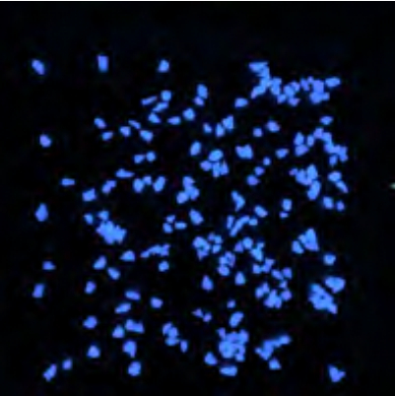 | 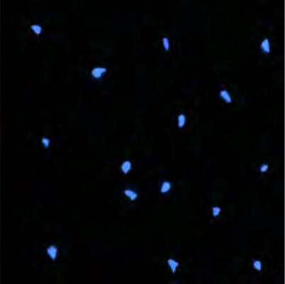
FULL  1 lb covers 1 sq.ft | MEDIUM  1 lb covers 8 sq.ft | EXTRA-LIGHT  1 lb covers 64 sq.ft
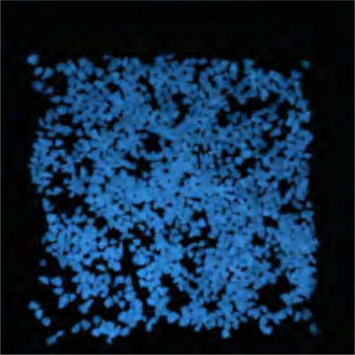 | 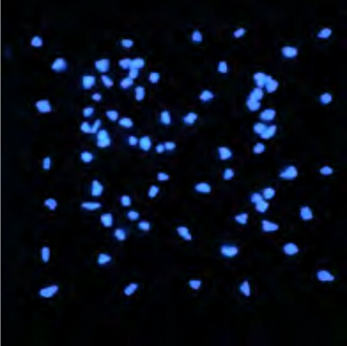 | 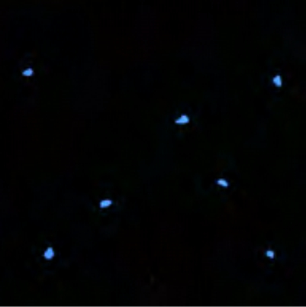
HEAVY  1 lb covers 2 sq.ft | MEDIUM-LIGHT  1 lb covers 16 sq.ft | SPARSE  1 lb covers 128 sq.ft
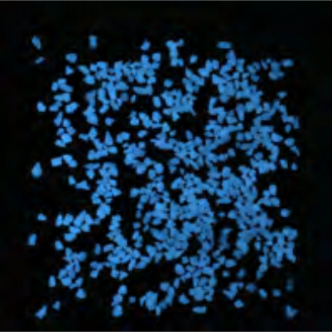 | 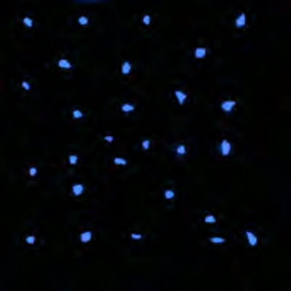
MED/HEAVY  1 lb covers 4 sq.ft | LIGHT  1 lb covers 32 sq.ft
A.1.5) 8-15MM QUANTUM GRADE AGGREGATE
€43,95
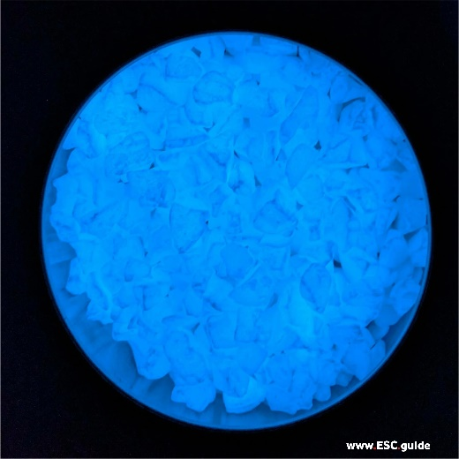 | 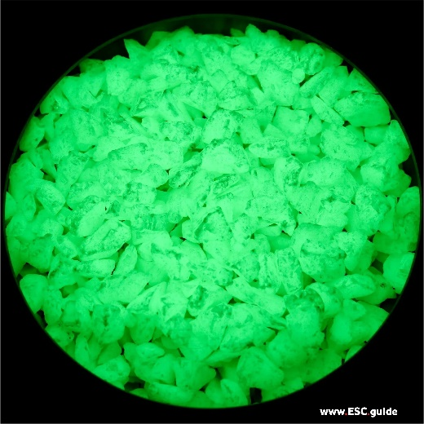 | 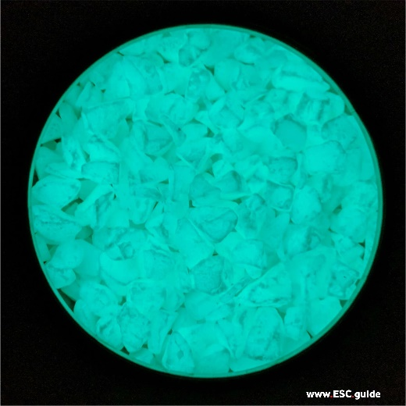
Blue 1lb | Green 1lb | Aqua 1lb
Ethereal Blue 8-15mm Quantum Glow:  Emission wavelength: 420nm  Optimum excitation wavelength: 200 - 450nm (standard and UV light)  Lux: 8 (0 hours), 2 (2-10 hours) | Hot Green 8-15mm Quantum Glow:  Emission wavelength: 520nm  Optimum excitation wavelength: 200 - 450nm (standard and UV light)  Lux: 10 (0 hours), 2 (2-10 hours) | Aqua Blaze 8-15mm Quantum Glow:  Emission wavelength: 480nm  Optimum excitation wavelength: 200 - 450nm (standard and UV light)  Lux: 8 (0 hours), 2 (2-10 hours)
NOTE: 8-15mm Blue Quantum is one of our most beautiful colours. The blue resembles a deep blue ocean while the aqua resembles the light blue of a tropical ocean. Blue quantum will last throughout the night but will not be quite as bright as aqua or green. | NOTE: 8-15mm Green Quantum is our brightest product ever. Green Quantum starts off the night as the brightest product available but keep in mind Quantum Aqua will match its brightness level within the first hour and later become even brighter. The 525 nm green emission wavelength is closer to the center of the visible region, where spectral sensitivity of the human eye is at a maximum. We recommend Hot Green or Aqua for large commercial and emergency exit uses. | NOTE: 8-15mm Aqua is highly recommended for paths and emergency exits as it holds the best glow throughout the night compared to other colours.
Our new Quantum product line has been formulated to maximize the brightness and longevity of the glow stones while ensuring no photoluminescent microcrystal is wasted. We increased our glow powder by 60% to create our new ultra-premium line, Quantum, for the best glow at the best price.

Quantum is:
- 60% more powerful than our commercial grade glow stones
- Glow Duration: 12+ Hours
- Charge time: 10-20 mins (UV preferred)
- Lifespan: 20+ years

Environmental Accountability: Quantum is a highly durable product, designed for long-term usage. We are committed to continuously innovating to make Core Glow products longer-lasting, more durable, and brighter, in order to continuously improve our environmental impact.
Coverage Guide
Based on 1 lb of Core Glow Commercial Grade Marble, 8-15 mm stone
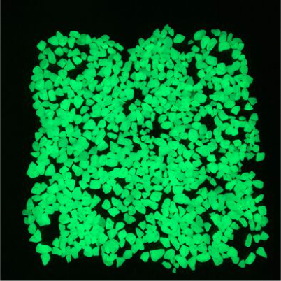 | 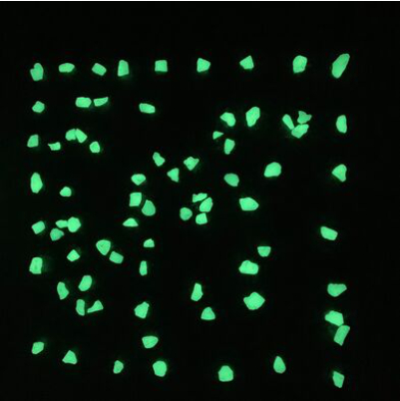 | 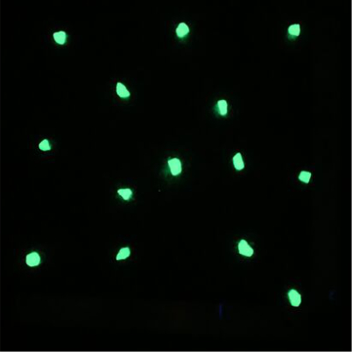
FULL  1 lb covers 1 sq.ft | MEDIUM  1 lb covers 8 sq.ft | EXTRA-LIGHT  1 lb covers 64 sq.ft
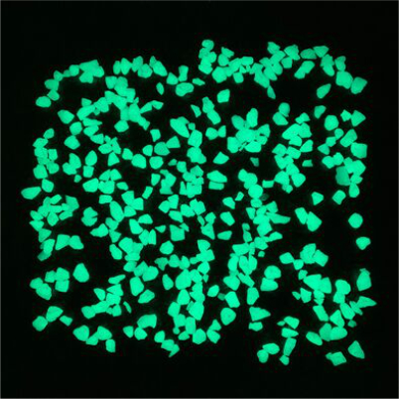 | 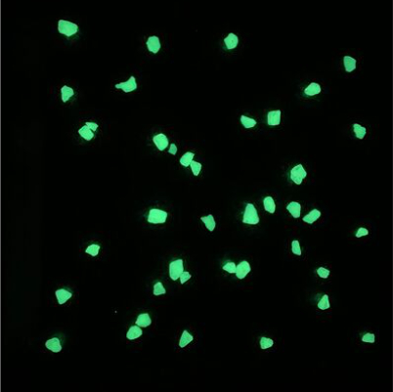 | 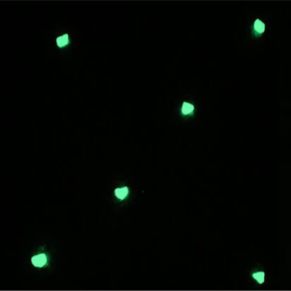
HEAVY  1 lb covers 2 sq.ft | MEDIUM-LIGHT  1 lb covers 16 sq.ft | SPARSE  1 lb covers 128 sq.ft
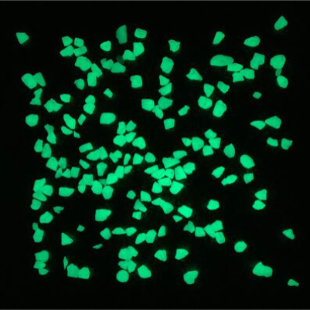 | 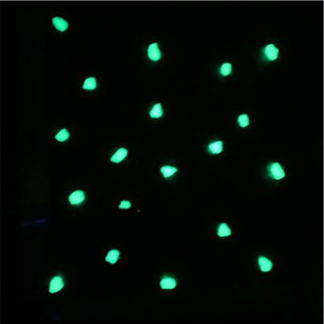
MED/HEAVY  1 lb covers 4 sq.ft | LIGHT  1 lb covers 32 sq.ft
A.1.6) 16-25MM QUANTUM GRADE AGGREGATE
€43,95
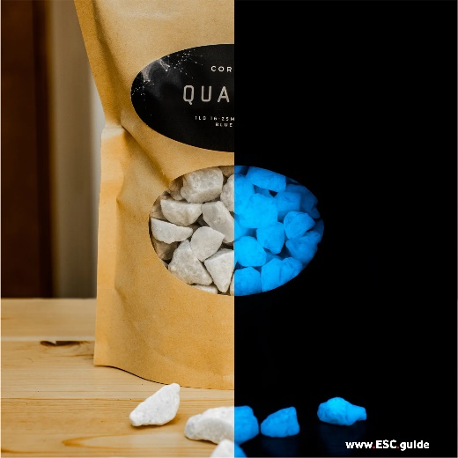 | 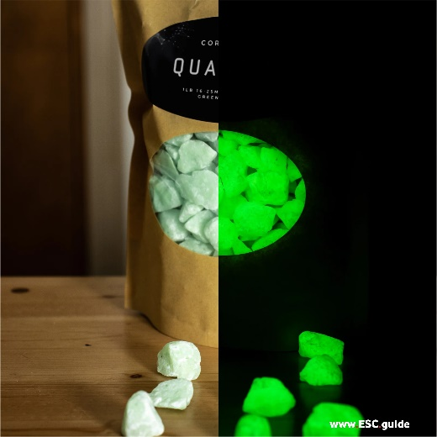 | 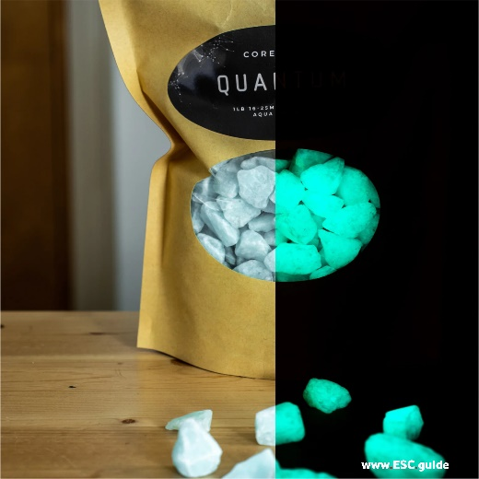
Blue 1lb | Green 1lb | Aqua 1lb
Ethereal Blue 16-25mm Quantum Glow:  Emission wavelength: 420nm  Optimum excitation wavelength: 200 - 450nm (standard and UV light)  Lux: 8 (0 hours), 2 (2-10 hours) | Hot Green 16-25mm Quantum Glow:  Emission wavelength: 520nm  Optimum excitation wavelength: 200 - 450nm (standard and UV light)  Lux: 10 (0 hours), 2 (2-10 hours) | Aqua Blaze 16-25mm Quantum Glow:  Emission wavelength: 480nm  Optimum excitation wavelength: 200 - 450nm (standard and UV light)  Lux: 8 (0 hours), 2 (2-10 hours)
Our new Quantum product line has been formulated to maximize the brightness and longevity of the glow stones while ensuring no photoluminescent microcrystal is wasted. We increased our glow powder by 60% to create our new ultra-premium line, Quantum, for the best glow at the best price.
Quantum is:
- 60% more powerful than our commercial grade glow stones
- Glow Duration: 12+ Hours
- Charge time: 10 mins (UV preferred)
- Lifespan: 20+ years

Environmental Accountability: Quantum is a highly durable product, designed for long-term usage. We are committed to continuously innovating to make Core Glow products longer-lasting, more durable, and brighter, in order to continuously improve our environmental impact.
Note: Green Quantum is the brightest product we offer. The 525 nm green emission wavelength is closer to the center of the visible region, where spectral sensitivity of the human eye is at a maximum. This is why we recommend Hot Green for industrial and safety applications.

A.1.7) CORE GLOW SAMPLE KIT
€23,95
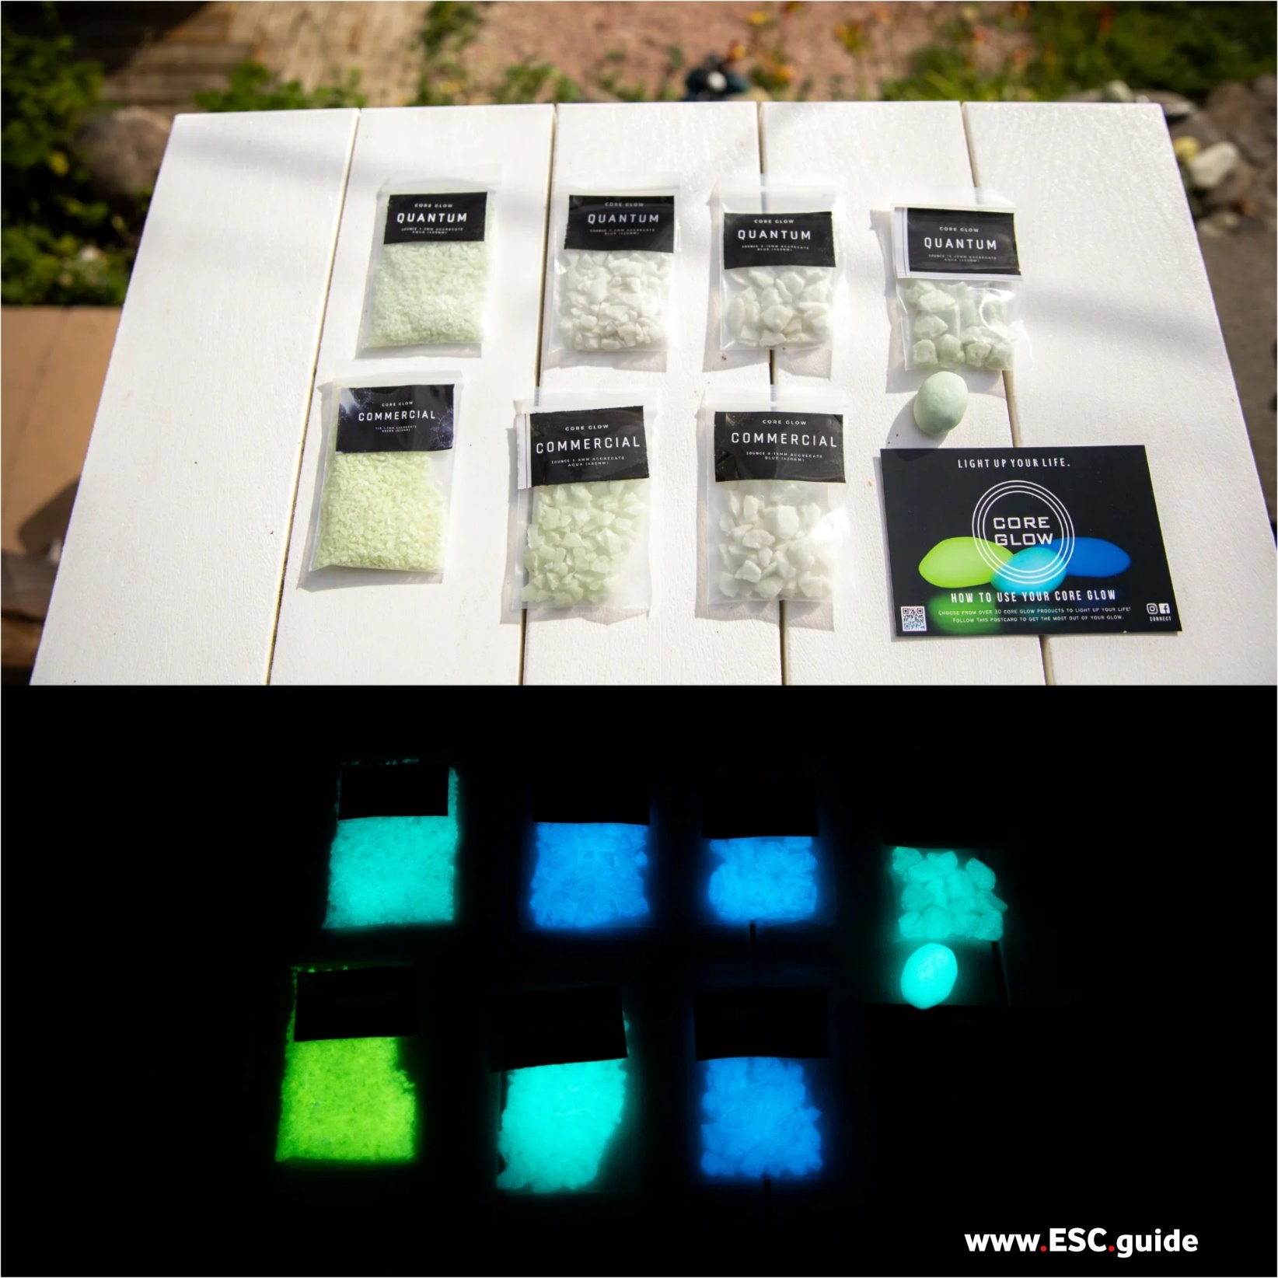

This Core Glow Sample Kit comes with a variety of sizes and colours. Receive both Commercial and Quantum grade aggregate to compare them for yourself!
Includes:
- 1-3mm Commercial
- 1-3mm Quantum
- 3-8mm Commercial
- 3-8mm Quantum
- 8-15mm Commercial
- 8-15mm Quantum
- 16-25mm Quantum
- 1 tiny boulder
- 1 mini UV light
- 1 CORE Glow card

Core Glow Commercial Grade Aggregates:
Core Glow Commercial Grade Aggregates are the industry standard in photoluminescent lighting. Engineered for professional and commercial applications, available in three distinct emission wavelengths; 420nm (green), 480nm (aqua) and 420nm (blue), are suitable for with a lifetime of over 20 years. Durable, rechargeable, and guaranteed awesome.
Core Glow Quantum Grade Aggregate:
Our new Quantum product line has been formulated to maximize the brightness and longevity of the glow stones while ensuring no photoluminescent microcrystal is wasted. We locked in at 60% additional pure glow powder for our new ultra-premium line, Quantum, for the best glow at the best price.
Core Glow products are compliant with Dark Sky guidelines for light pollution reduction.

A.2.8) 1-3MM COMMERCIAL GRADE AGGREGATE
€37,95 (1lb) / €128,95 (4lb)
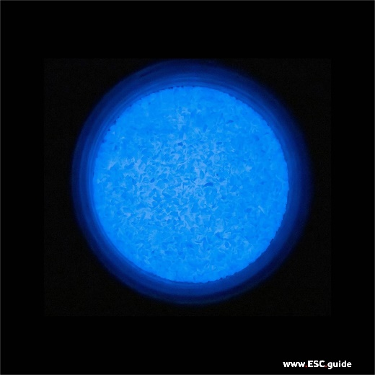 | 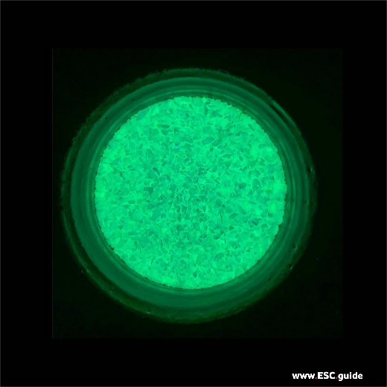 | 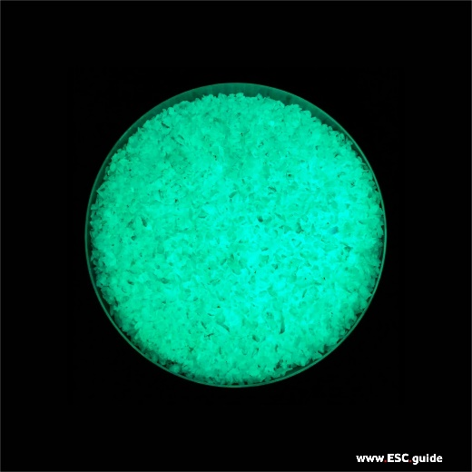
Blue | Green | Aqua

Our smallest chips are made for smoothing into concrete surfaces, countertops, flooring, and more. Create an illusion of depth by mixing with other CORE Glow Commercial Grade Natural Stone sizes.
Size Range: 1-3mm
Colour: Ethereal Blue: the softest and calming glow at 420nm. Perfect for spas, relaxing walkways, indoor bathrooms, meditative landscapes, and falling into other dimensions.
Quantity: 1lb. Inquire about bulk orders.
Coverage:
Light Coverage: 1lb/16 sq ft (galaxy effect)
Full Coverage: 1lb/0.5 sq ft
Consider mixing with CORE Glow 8-15mm Commercial Grade marble for a range of sizes. This creates an illusion of depth, just like bright and dim stars in the night sky.
Core Glow Commercial Grade Aggregates: CORE Glow Commercial Grade Aggregates are the industry standard in photoluminescent lighting. Engineered for professional and commercial applications, available in three distinct emission wavelengths; 420nm (green), 480nm (aqua) and 420nm (blue), with a lifetime of over 20 years, and are suitable replacements for gravel aggregates. Durable, rechargeable, and guaranteed awesome.
Core Glow products are compliant with Dark Sky guidelines for light pollution reduction.
A.2.9) 3-8MM COMMERCIAL GRADE AGGREGATE
€37,95 (1lb) / €128,95 (4lb)
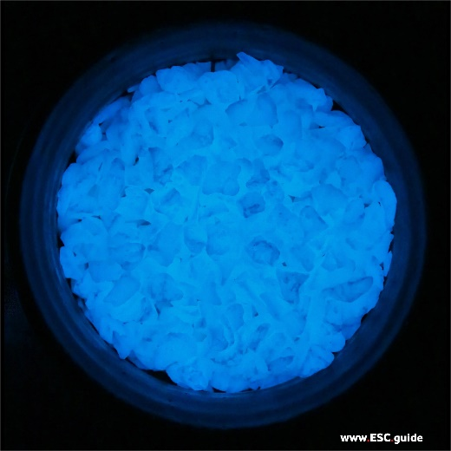 | 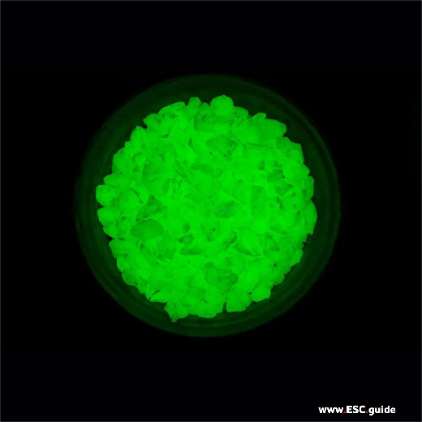 | 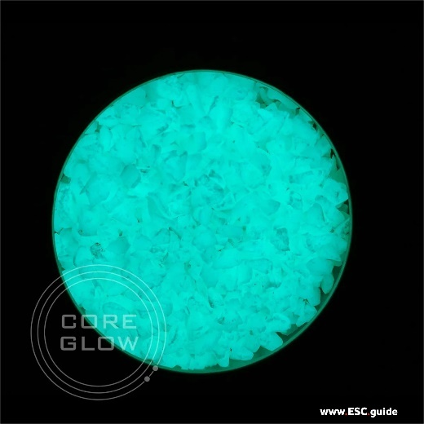
Blue | Green | Aqua

Our medium-sized 3-8mm aggregates are made for smoothing into concrete surfaces, countertops, flooring, roadways, paths, and more.
Size Range: 3-8mm
Colour: Ethereal Blue: the softest and calming glow at 420nm. Perfect for spas, relaxing walkways, indoor bathrooms, meditative landscapes, and falling into other dimensions.
Quantity: 1lb. Inquire about bulk orders.
Coverage:
Scattered Coverage: 1lb/16 sq ft (galaxy effect)
Full Coverage: 1lb/0.5 sq ft
Consider mixing with CORE Glow 8-15mm Commercial Grade marble for a range of sizes. This creates an illusion of depth, just like bright and dim stars in the night sky.
Core Glow Commercial Grade Aggregates: CORE Glow Commercial Grade Aggregates are the industry standard in photoluminescent lighting. Engineered for professional and commercial applications, available in three distinct emission wavelengths; 420nm (green), 480nm (aqua) and 420nm (blue), with a lifetime of over 20 years. Durable, rechargeable, and guaranteed awesome.
CORE Glow products are compliant with Dark Sky guidelines for light pollution reduction.
A.2.10) 8-15MM COMMERCIAL GRADE AGGREGATE
€37,95 (1lb) / €128,95 (4lb)
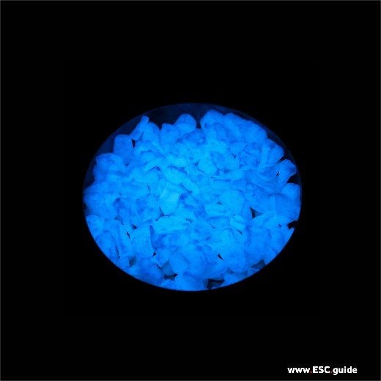 | 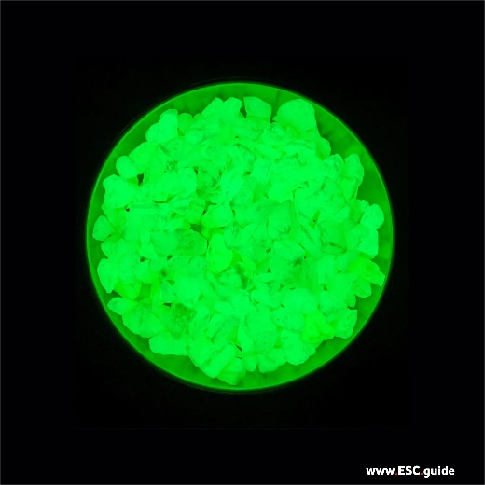 | 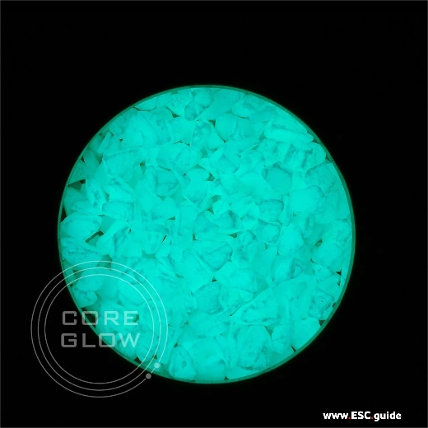
Blue | Green | Aqua

Our 8-15mm aggregates are made for smoothing into concrete surfaces, countertops, flooring, roadways, paths, and more.
Size Range: 8-15mm
Colour: Ethereal Blue: the softest and calming glow at 420nm. Perfect for spas, relaxing walkways, indoor bathrooms, meditative landscapes, and falling into other dimensions.
Quantity: 1lb. Inquire about bulk orders.
Coverage:
Scattered Coverage: 1lb/16 sq ft (galaxy effect)
Full Coverage: 1lb/0.5 sq ft
Consider mixing a range of CORE Glow Commercial Grade marble sizes. This creates an illusion of depth, just like bright and dim stars in the night sky.
Core Glow Commercial Grade Aggregates: CORE Glow Commercial Grade Aggregates are the industry standard in photoluminescent lighting. Engineered for professional and commercial applications, available in three distinct emission wavelengths; 420nm (green), 480nm (aqua) and 420nm (blue), with a lifetime of over 20 years. Durable, rechargeable, and guaranteed awesome.
CORE Glow products are compliant with Dark Sky guidelines for light pollution reduction.
A.2.11) SCIENCE OF GLOW GIFT BOX
€71,95
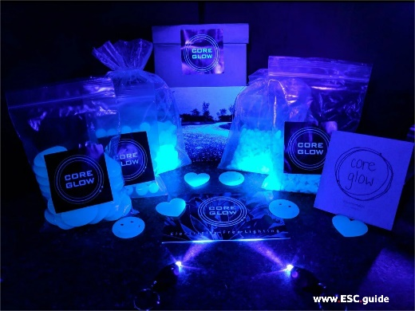 | 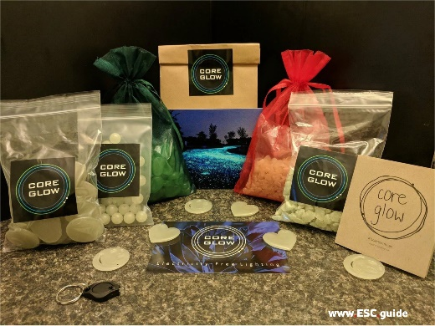 | 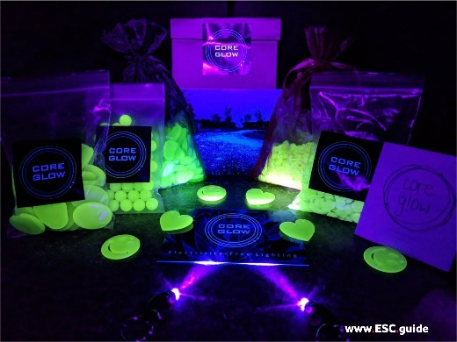
Core Glow Science of Glow gift boxes are perfect for exploring the science behind the incredible glow-in-the dark effect of all Core Glow stones, for young and young-at heart science enthusiasts alike. Science of Glow exploration kits come packed full of our full range of products. #sciencemagic
Gift set includes: (Ethereal Blue)
- 1/2 lb of 1" white/blue glow stones
- 1/2 lb of 2" white/blue glow stones
- 1/2 lb of 3-8mm white/blue commercial grade marble
- 1/2 lb of 8-15mm white/blue commercial grade marble
- 50 white/blue beads
- 3 white/blue hearts
- 3 white/blue smileys
- LED UV Light
- Brochure and postcard

A.3.12) TINY BOULDERS
€43,95
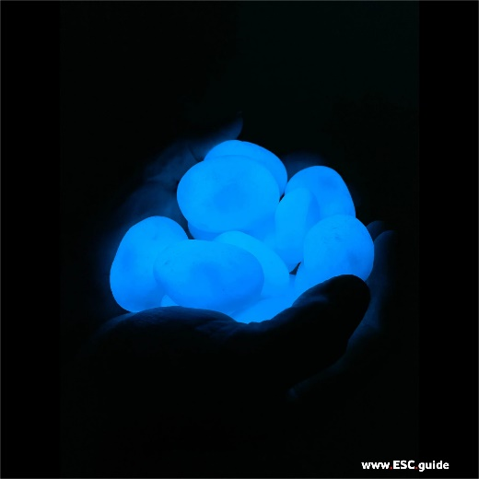 |  | 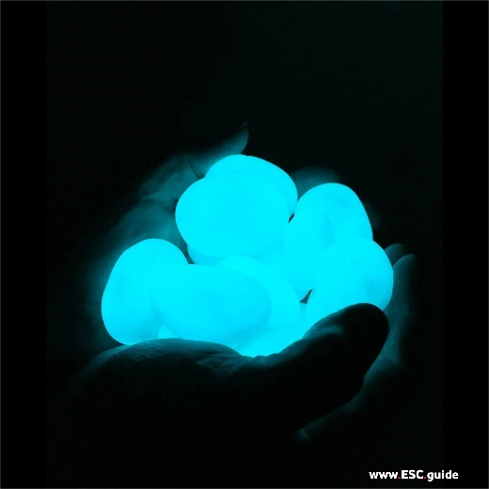
Blue | Green | Aqua

NEW TINY BOULDERS - 14-16 PER PACK (~2 inches)
We have created a tiny Quantum Boulder (ok, really just a downsized boulder) that is 100% glow! That's right, 100% through and through: no center rock or pumice, just solid Quantum. Take a close look at the photos; we're sure you'll agree, the smooth matte finish and glow intensity is perfecto!
14-16 boulders per pack
Size range: 1.5" - 2"
Colour: Blue, Green, Aqua
Glow Duration: 12+ Hours Every Night
Charge Time: 10 minutes of direct light (UV Preferred)
Which Color is the Brightest?: Aqua has proven itself to be the brightest through the course of the night, followed by green then by blue. However, Green is the brightest for the first one hour of glow but is then surpassed by Aqua.
Note: Sizes and weight may vary per pack

A.3.13) QUANTUM PACK
€22,95
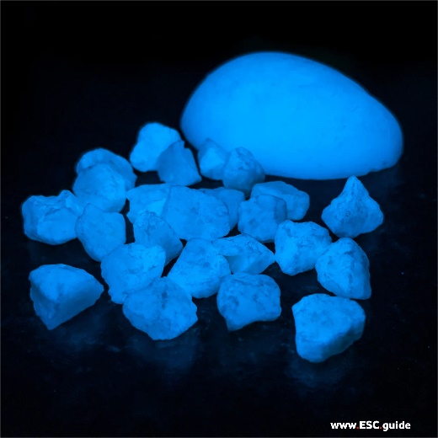 | 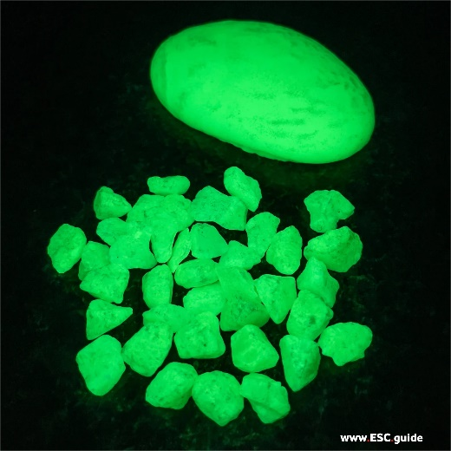 | 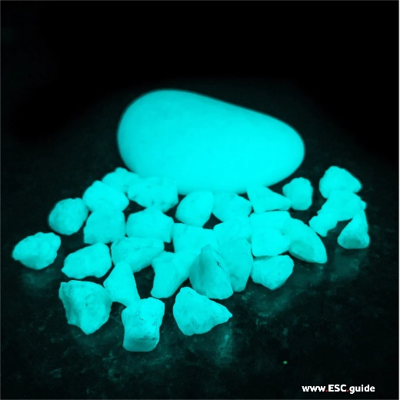
Blue | Green | Aqua

Quantum Pack
Love our Quantum products, but only need a small amount or want to try a variety? Then we've got the pack for you! Get one Quantum Boulder and 20-30 Quantum rocks!
What's inside?
- 1 Blue/Green/Aqua Quantum half Cut Boulder (4-6 inches)
- 20-30 of our 16-25mm Blue/Green/Aqua Quantum Rocks!
Shapes and sizes of all products will vary
Each pack is one color only, so select from aqua, blue, green or buy all three!

A.3.14) HALF CUT QUANTUM BOULDERS (3 PACK) FINAL PROTOTYPE!
€43,95
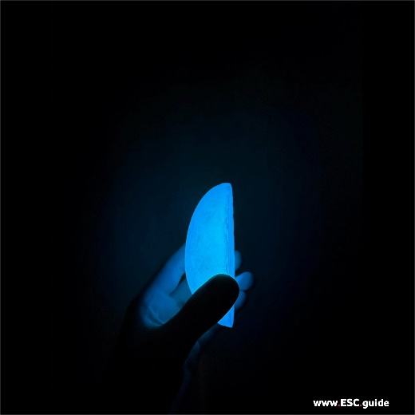 | 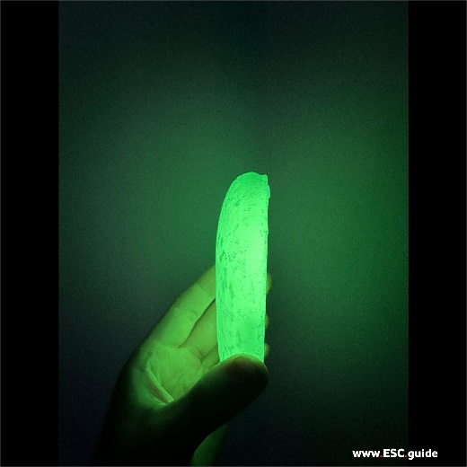 | 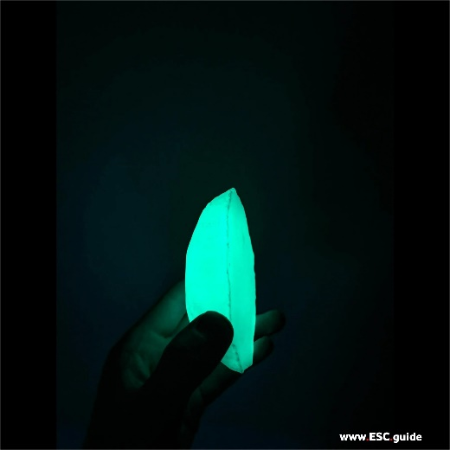
Blue | Green | Aqua

Half Cut Quantum Heavyweight Boulders are now bigger, better, and brighter!
With our new half cut design you are now getting twice as much glow for less!
We have created a half-cut Quantum Boulder that is 100% glow! That's right, 100% through and through: no centre rock or pumice, just solid Quantum. Sure to sit flat on your garden, pathway, driveway and more! Take a close look at the photos; we're sure you'll agree, the smooth matte finish and glow intensity is perfecto!
The sheer mass of this product creates a glow like no other! Lighting up the area around it all night long.
Three half cuts cover more surface area than three full-size boulders for significantly less money. Save money and get more!
3 boulders per pack
- Colour: Blue, Green, Aqua
- Glow Duration: 12+ Hours Every Night
- Charge Time: 10 minutes of direct light (UV Preferred)

Which Color is the Brightest?: Aqua has proven itself to be the brightest through the course of the night, followed by green then by blue. However, Green is the brightest for the first one hour of glow but is then surpassed by Aqua.
Note: Sizes and weight in your order may vary

A.3.15) HALF CUT QUANTUM BOULDER MIX PACK FINAL PROTOTYPE!
€47,95
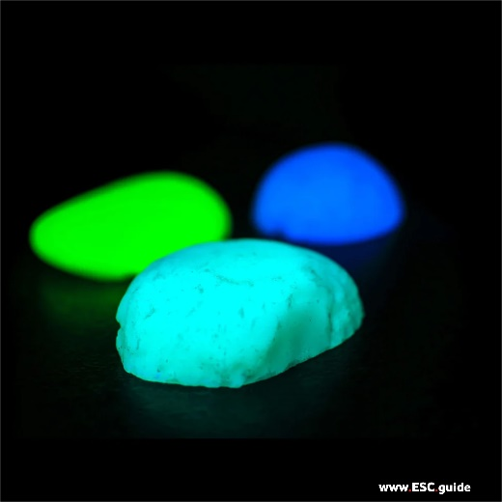

Half Cut Quantum Heavyweight Boulders are now bigger, better, and brighter!
With our new half-cut design you are now getting twice as much glow for less!
We have created a half-cut Quantum Boulder that is 100% glow! That's right, 100% through and through: no centre rock or pumice, just solid Quantum. Sure to sit flat on your garden, pathway, driveway and more! Take a close look at the photos; we're sure you'll agree, the smooth matte finish and glow intensity is perfecto!
The sheer mass of this product creates a glow like no other! Lighting up the area around it all night long.
Three half cuts cover more surface area than three full-size boulders for significantly less money. Save money and get more!
Each pack comes with 1 of each colour!
Colour: Aqua, Green, and Blue!
Glow Duration: 12+ Hours Every Night
Charge Time: 10 minutes of direct light (UV Preferred)
Which Color is the Brightest?: Aqua has proven itself to be the brightest through the course of the night, followed by green then by blue. However, Green is the brightest for the first one hour of glow but is then surpassed by Aqua.
Note: Sizes and weight in your order may vary

A.4.16) 1” STONES
€19,95
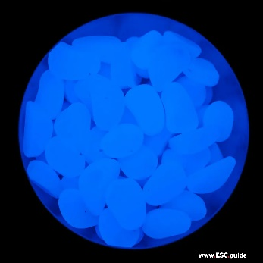 | 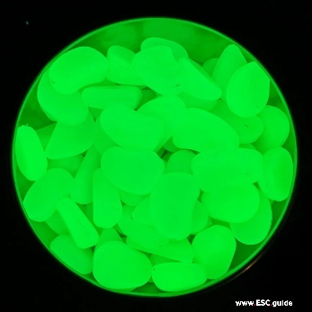 | 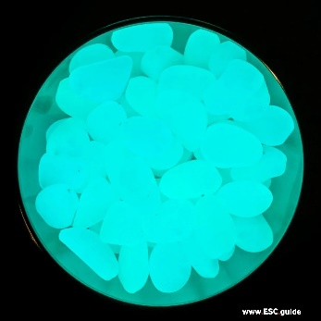 | 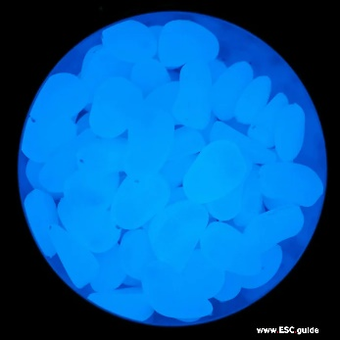
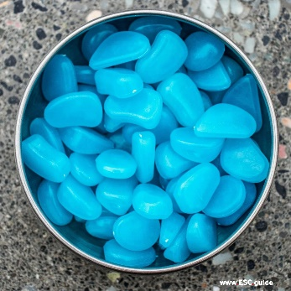 | 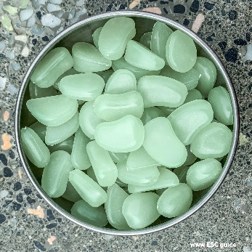 | 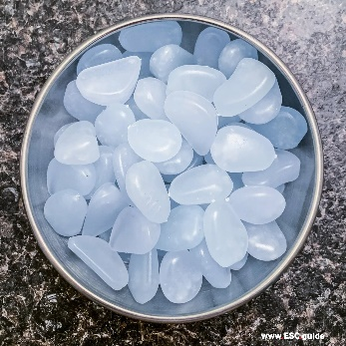 | 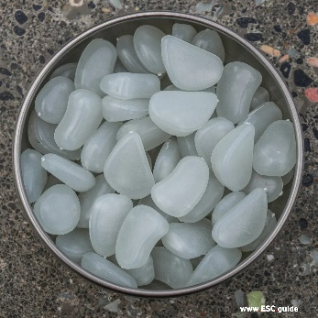
1" BLUE (BLUE) STONES | 1" GREEN (GREEN) STONES | 1" AQUA (AQUA) STONES | 1" WHITE (BLUE) STONES
1lb bag: ~135 stones | 1lb bag: ~135 stones | 1lb bag: ~135 stones | 1 lb bag: ~60 pieces
CORE Glow stones are the perfect addition for indoors and outdoor lighting and decoration. These stones are durable, all-weather and long-lasting composite stones.
Please note these are NOT suitable to be embedded in concrete or asphalt as they are made of plastic.
Half-Life: 20 Years
Glow Duration Each Night: 8-12 Hours
Charge Time: 10-20 Minutes (UV Preferred)

A.4.17) 2” COBBLES
€22,95
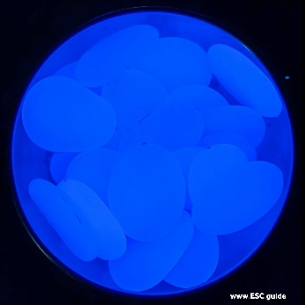 | 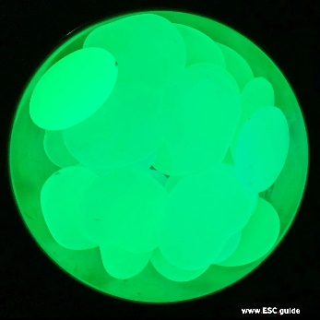 | 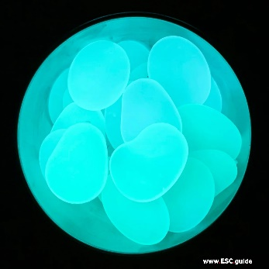 | 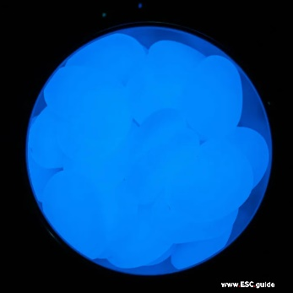
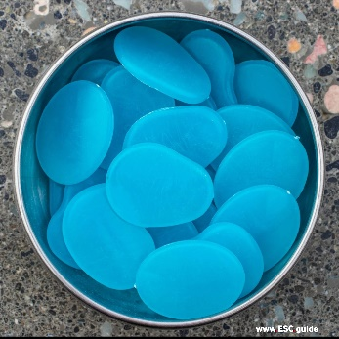 | 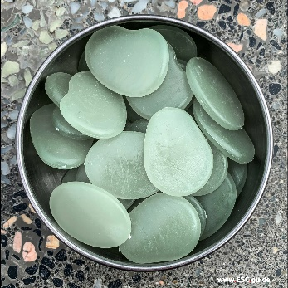 | 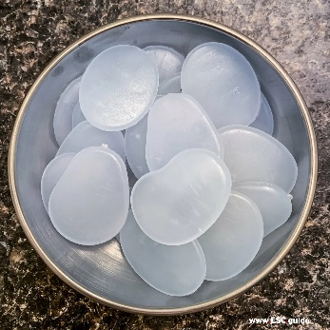 | 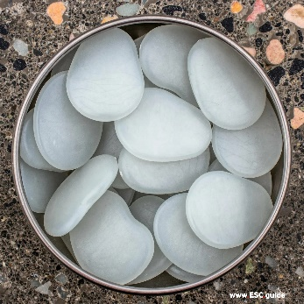
2" BLUE (BLUE) COBBLES | 2" GREEN (GREEN) COBBLES | 2" AQUA (AQUA) COBBLES | 2" WHITE (BLUE) COBBLES
1 lb bag: ~60 pieces | 1 lb bag: ~60 pieces | 1lb bag: ~135 stones | 1 lb bag: ~60 pieces

CORE Glow stones are the perfect addition for indoors and outdoor lighting and decoration. These stones are durable, all-weather and long-lasting composite stones.
Please note these are NOT suitable to be embedded in concrete or asphalt as they are made of plastic.
Half-Life: 20 Years
Glow Duration Each Night: 8-12 Hours
Charge Time: 10-20 Minutes (UV Preferred)

A.4.18) SCIENCE OF GLOW GIFT BOX
€71,95
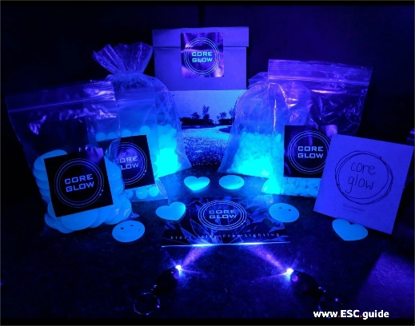 | 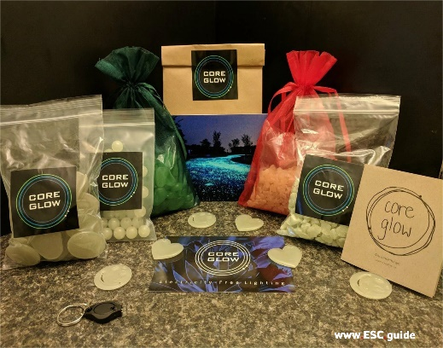 | 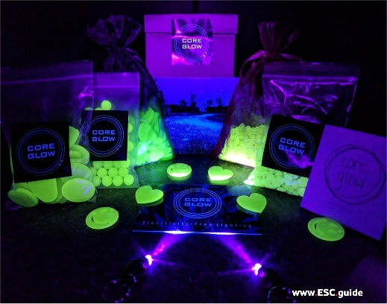

Core Glow Science of Glow gift boxes are perfect for exploring the science behind the incredible glow-in-the dark effect of all Core Glow stones, for young and young-at heart science enthusiasts alike. Science of Glow exploration kits come packed full of our full range of products.
Gift set: (Hot Green)
- 1/2 lb of 1" green glow stones
- 1/2 lb of 2" green glow stones
- 1/2 lb of 3-8 mm commercial grade marble
- 1/2 lb of 8-15 mm commercial grade marble
- 50 white/green beads
- 3 white/green hearts
- 3 white/green smileys
- LED UV Light (while supplies last)
- Brochure and postcard

A.4.19) SCIENCE OF GLOW FOR KIDS
€39,95
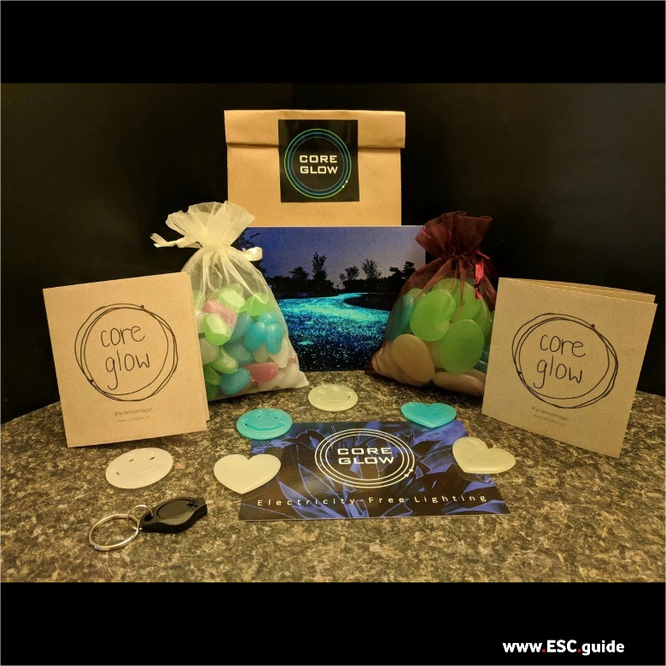 | 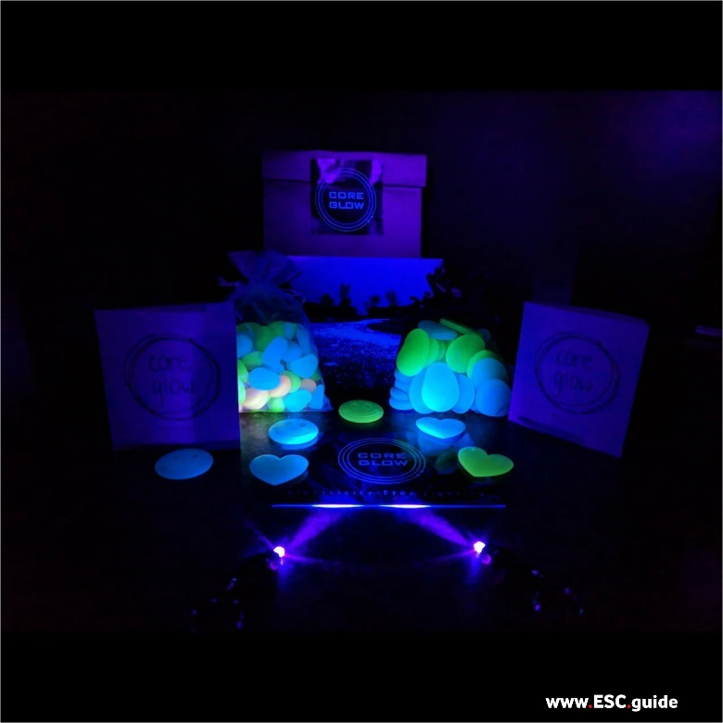

CORE Glow Science of Glow for Kids gift boxes are perfect for exploring the science behind the incredible glow-in-the dark effect of all Core Glow stones, for young and young-at heart science enthusiasts alike. Science of glow exploration kits come packed full of playful, fun glow-in-the-dark products! #sciencemagic
Gift set: (Kids Multi-color)
- 1/2 lb mix of all 2" glow stones (blue, green and white/blue)
- 1/2 lb mix of all 1" glow stones (blue, green, and white/blue)
- Hearts (blue, green and white/blue)
- Smileys (blue, green and white/blue)
- LED UV Light (while supplies last)
- Brochure and postcard

A.4.20) GLOW BEADS
€17,95
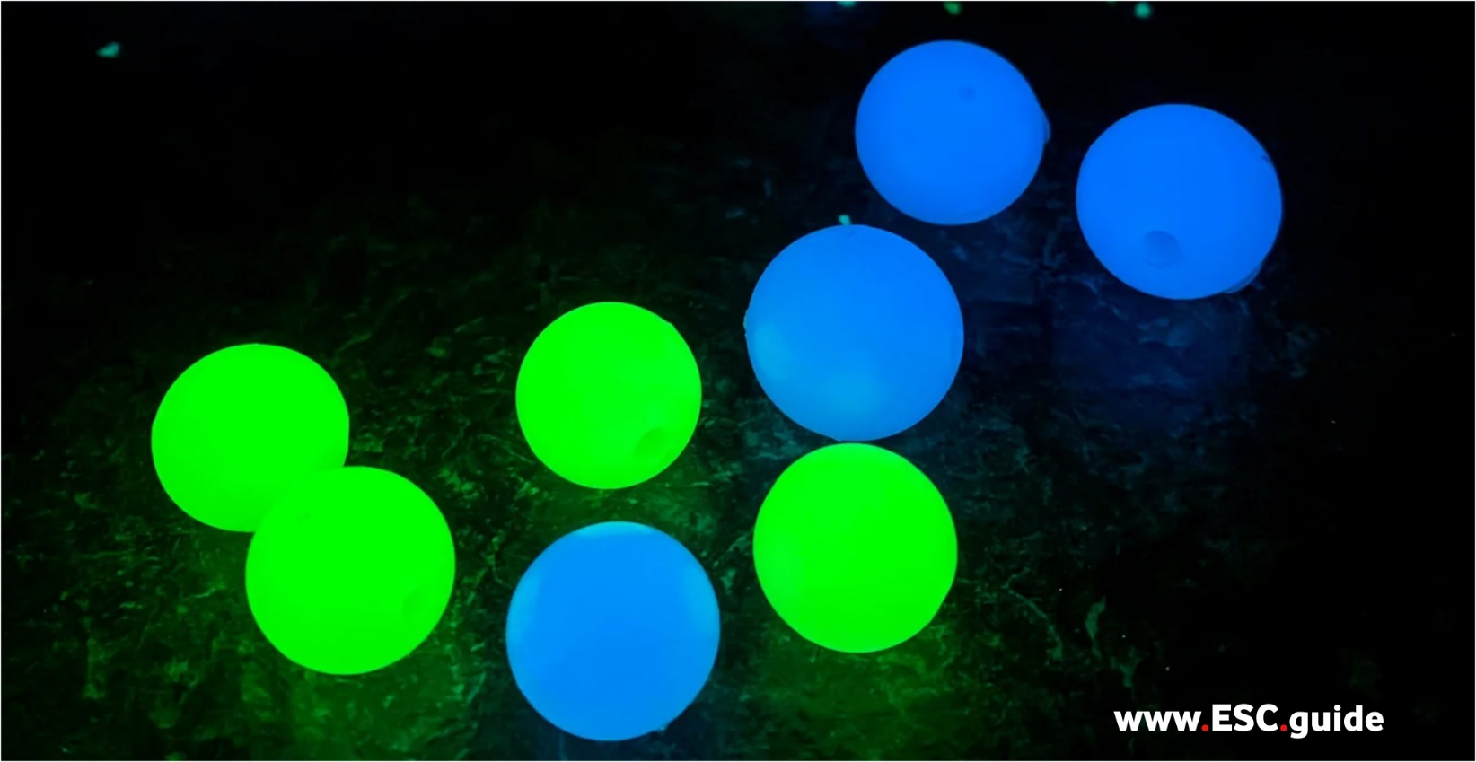
CORE Glow beads are the perfect addition for indoors and outdoor lighting and decoration. Rumour has it they are REALLY great on fishing lures.
Glow Duration Each Night: 8-12 Hours
Quantity: 1lb bag containing ~100 beads
Sizes: 15mm and 18mm
Colours: Blue or Green

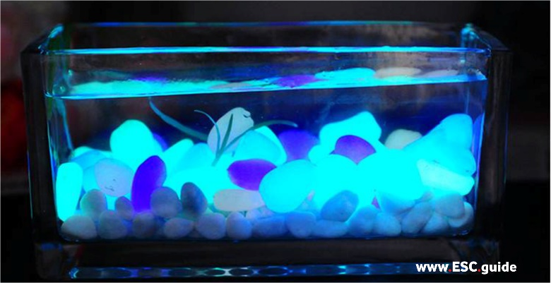 | 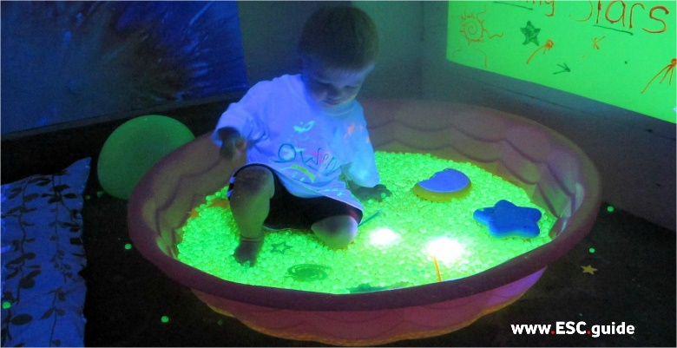
B. FAQ’s
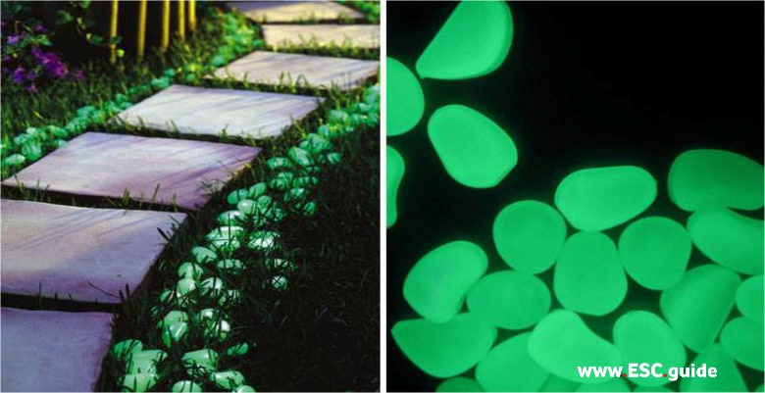
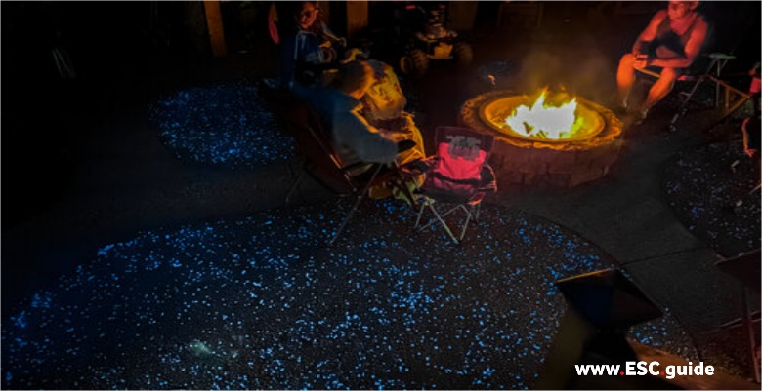 | 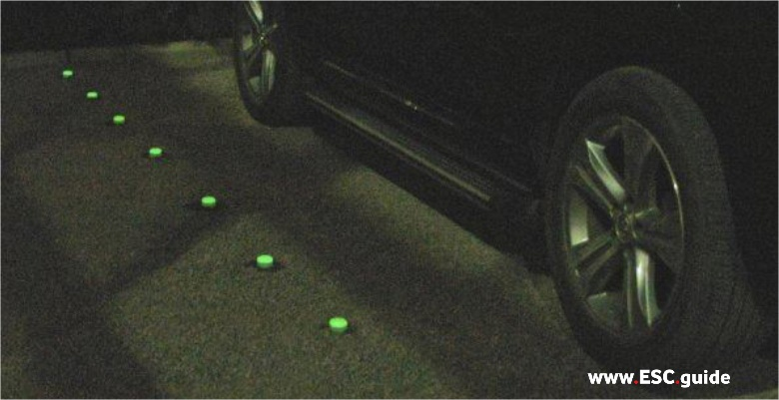
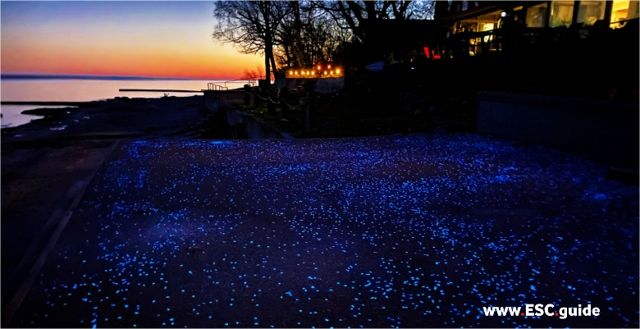 | 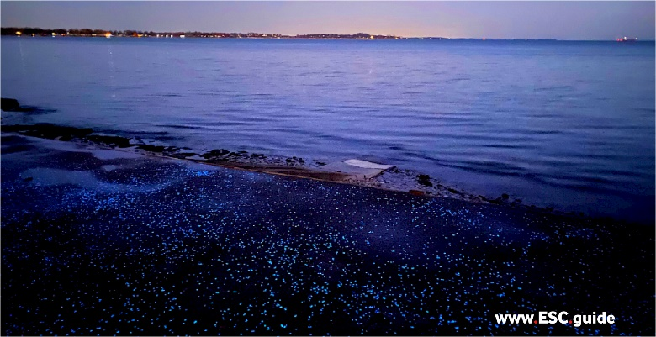

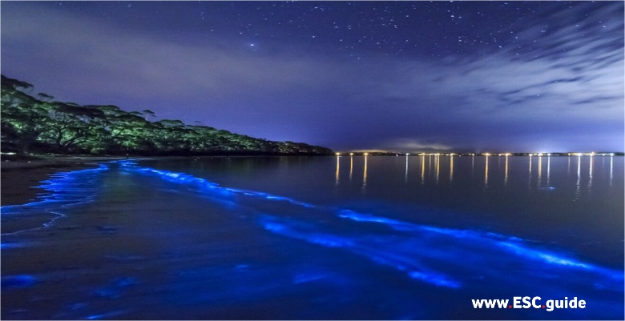
B.1. General Questions about CORE Glow
B.2. Project Related Questions
B.3. Pricing Questions

B.1. General Questions:
Q. How does Core Glow work?
Quick answer: All Core Glow products contain a photoluminescent compound that absorbs light energy in the form of photons. These are slowly re-emitted it at a lesser wavelength over a long period of time.
Full answer: All Core Glow products contain a photoluminescent crystalline compound, SrAl2O4, which absorbs light energy in the form of photons. The photons are slowly released over a long period of time which gives the Core Glow its constant glow. The light produces no heat of its own while undergoing this state change - not quite cold fusion but pretty neat nonetheless. The colour of the glow depends on the number of oxygen molecules in the compound. The presence of oxygen slightly alters the crystal field structure resulting in a change in the wavelength emitted when glowing:
- Green SrAl2O4: 520nm
- Aqua SrAl2O7: 480nm
- Blue SrAl2O19: 420nm
Q. How long should I charge Core Glow stones?
Quick Answer: 1 minute for a quick burst, 1 hour for a full charge. Sunlight (broad spectrum) and UV lights work best, incandescent bulbs second, and LED, fluorescent, etc. third.
Full Answer: any exposure to light will excite the Core Glow compound, giving it a small charge, causing it to glow. The trick is to 'saturate' the Core Glow with as much light as it can take to ensure the long afterglow. This takes half an hour to an hour (just to be safe). UV lights work great for a quick burst of supercharged glow but this will not result in a full charge. Low light and shaded areas with ambient light will not result in a bright immediate glow but will charge the stones enough for a long afterglow.
Q. How long do the Core Glow stones last after a charge?
Quick answer: 8-12 hours
Full answer: Core Glow is always glowing, it just depends on whether your eyes can see it. During the day Core Glow is constantly absorbing light energy, especially if placed in direct sunlight or under a bright lightbulb. If you were to place it in a dark room you would see that it is glowing the whole time. Core Glow emits 5-7 candelas of light during its soft 'ambient glow' phase - compare to electric lights which emit hundreds. Initially, after a charge Core Glow will be so bright you can see it glowing even in a well-lit room, and it will cast light on the walls. After 45 min-1hr it will fade to a softer bright glow, and after 2 hours will settle into its ambient glow phase that will last all night. For this reason, it is best to view Core Glow in complete darkness- charge them up then give your eyes time to adjust. You will see them glow all night long.
Q. What is the lifespan of Core Glow stones?
Quick answer: 20+ years
Full answer: the photoluminescent compound in Core Glow is biologically and chemically inert. With proper maintenance, your glow rocks will glow indefinitely.
Q. Is Core Glow stones safe?
Quick Answer: Yes
Full Answer: Core Glow's photoluminescent compound, SrAl2O4 has been certified as safe by OSHA and ANSI standards. This means it has undergone rigorous product testing via international agencies before approval for commercial sale. It is biologically and chemically inert, does not contain high levels of dangerous elements or heavy metals, and has been embraced worldwide as an incredible improvement on the glow technology of the past - Zinc Copper Sulphide and its derivatives. Now, does this mean we will encourage you to eat it and treat it with disregard? No. The powder (when airborne) is a respiratory irritant and should be handled with respect using proper safety equipment (ask for our MSDS sheet). Also, keep the Core Glow away from babies and children who may be curious enough to try eating Core Glow. Safety first!
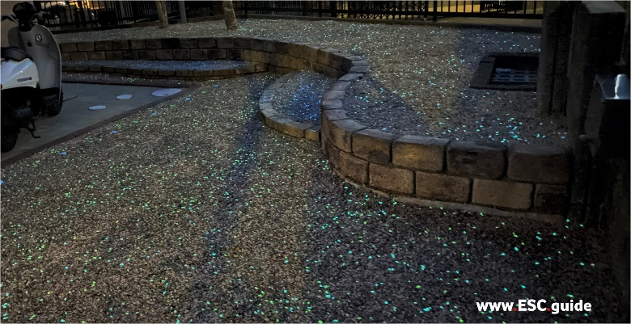 | 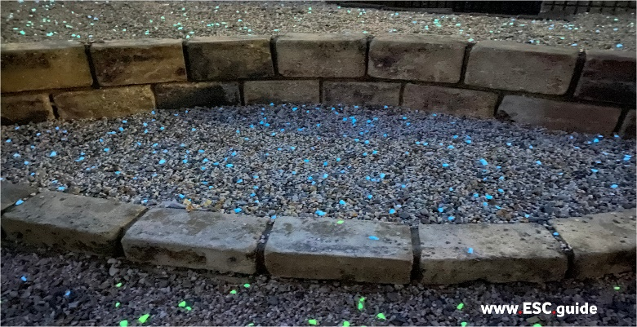
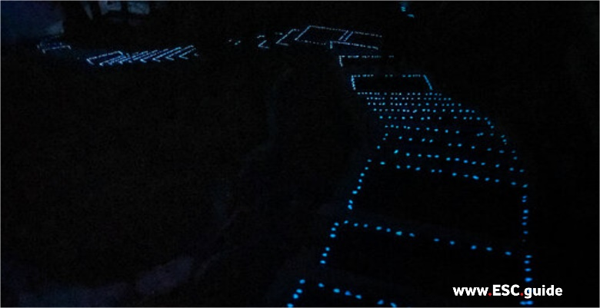 | 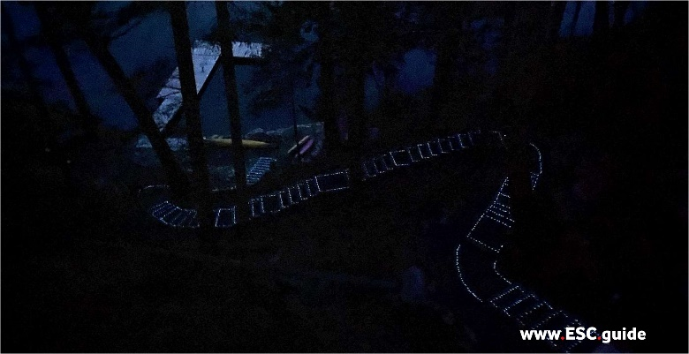
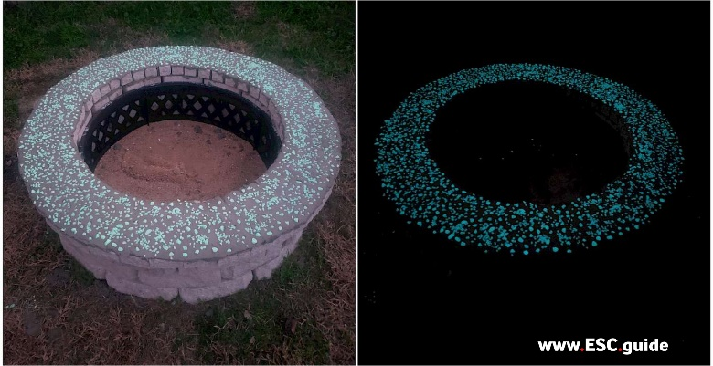 | 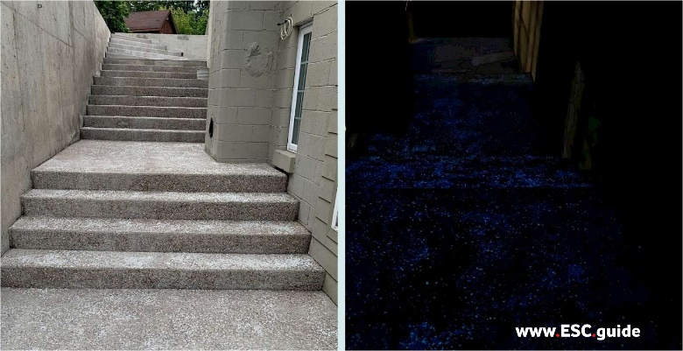

B.2. Project Related Questions:
Q. I am thinking of starting a glow project. What do I need to know?
Quick Answer: Everything you need to know is in our Core Glow Project Guide.
Long Answer: The best place to start is by reading through our Core Glow Project Guide. We have compiled our own experience into tips, charts, and troubleshooting help so your project will turn out just how you imagined. Have a question that isn't answered? Get in touch via our contact form.
Q. How much Core Glow will I need to make my driveway, patio, the stairway to heaven, etc. glow?
Quick Answer: You will need 1lb per 16 sq ft for 'high density dispersed coverage' - this results in the 'walking in a galaxy' effect.
Full Answer: Visit our 'Coverage' page for a more in-depth answer to this question or if you want to install over an existing landscape. Generally, we recommend 1lb per 16 sq ft for that 'walking in a galaxy' effect. In other words, this is how much you will need for 'high density dispersed coverage'. Tweak the measurements up or down to match your coverage preferences and budget restraints. If you want full coverage Core Glow Commercial Grade Marble covers 0.5 sq ft/lb.
Q. How do I make a glowing driveway and/or pathway like the one in your photos?
Quick Answer: Make your own glow path or driveway with our easy handy packs including gravel stabilizing the grid, pre-attached geotextile sheets, and info on how much Core Glow to add. It's that easy.
Full Answer: Use Core Handypacks to easily install your own glowing, stable, and permeable pathways, patios, and driveways. Simply level the area you want to be covered, lay down the grid, fill will gravel, and top with Core Glow. For an in-depth look at the grid system visit www.coregravel.ca/greece.
Q. Does the area need to be in full direct sunlight for Core Glow to charge?
Quick Answer: No, but it will work best if it does.
Full Answer: Direct sunlight will fully charge Core Glow and result in a bright initial charge. In an area that gets partial sun, the Core Glow will receive a charge, but it may begin its 'ambient glow cycle' by the time night falls and may not hold the charge through the night. Also, note that light pollution in your area will render the glow invisible. Core Glow is best viewed in complete darkness away from electric street lamps, solar lights, and other electric light sources. Core Glow is best viewed under the moon and stars alone, ahhh. For more tips on how to optimize your Core Glow project read through our Project Guide.
Q. Can I use my indoor lights to charge Core Glow for my indoor project?
Quick Answer: Absolutely.
Full Answer: Indoor lights work very well to charge Core Glow, and gives you control over how much light they will receive. The best charge comes from a light pointed directly at Core Glow. You can use a UV light to supercharge an area to impress your guests and freak out your cat. For a comprehensive list of best lighting conditions take a look at our Project Guide.
Q. Will sanding, shaping, or cutting Core Glow affect its ability to glow?
Quick Answer: Not one bit.
Full Answer: All of our Core Glow products are fully saturated with the photoluminescent compound rather than just being top coated. This means you can shape, sand, cut, smash, fracture, do whatever you want to Core Glow and it will still glow just as brightly as when it made its way to you. You may even notice it begin to glow as you sand or cut the Core Glow as the compound is also friction reactive!
- check out our Project Guide for step by step instructions on how to embed Core Glow into cement, sanding optional.
Q. How do I know which type of Core Glow to choose for my project?
Quick Answer: Read through our Project Guide page for an in-depth rundown of how to choose the best Core Glow for your project.
Full Answer:
- Commercial and Professional projects: Core Glow Quantum or Commercial Grade Marble
- Permanent cement projects (indoor and outdoor): Core Glow Quantum or Commercial Grade Marble
- Permanent cement projects (indoor only): Core Glow Quantum or Commercial Grade Marble
- Artistic Endeavors: Core Glow Quantum or Commercial Grade Marble
- General landscaping: Core Glow Quantum and Commercial Grade Marble, and Core Glow Stones
- Fun projects: Core Glow Stones
- Gifts: Core Glow Gift Sets
Q. How is Core Glow Quantum different from Commercial Grade Marble and from CORE glow stones?
Quick Answer: Core Glow Quantum Grade Marble has the brightest and longest glow of all of the Core Glow products. Quantum glow has 2x as much SrAl2O4 by volume than our Commercial Grade and 5x as much by volume than CORE glow stones.
Full Answer: CORE glow marble is a cold manufactured process vs the high heat production for our Core Glow Stones. High heat limits the concentration of glow that can be achieved. This cold treatment method is tricky, time-consuming, and worth it for the brightest and longest-lasting Glow available. Not to mention the strength, quality, and natural look of the Core Glow Quantum and Commercial Grade Marble stone is simply the best.
Q. Do you offer Core Glow Samples?
Quick Answer: Yes - you can purchase a regular or commercial sample pack from our 'Shop' page
Full Answer: Core Glow samples cover all of our Core Glow products except Core Glow Powder. A great way to test out our products before choosing which type and colour to purchase for your project.

B.3. Pricing Questions:
Q. I have a large project. Do you offer volume discounts?
Quick Answer: Yes, we offer bulk pricing for orders greater than 50 or 100 lbs (product type dependent).
Full Answer: For large projects requiring over 100lbs of Core Glow stones please get in touch for volume pricing information.
Q. I am working on a public project/for a non-profit. Do you offer compassion rates?
Quick Answer: Yes we do! Please get in touch for your personalized discount code.
Full Answer: We are so impressed with all of the amazing projects that are out there. If you want to add a Core Glow touch please let us know the type of project, your audience, and the ethics behind your project. If you are working with significant budget restraints please let us know.
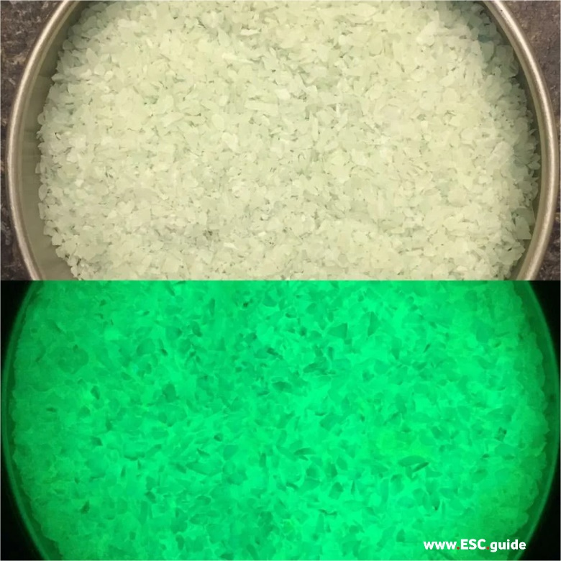 | 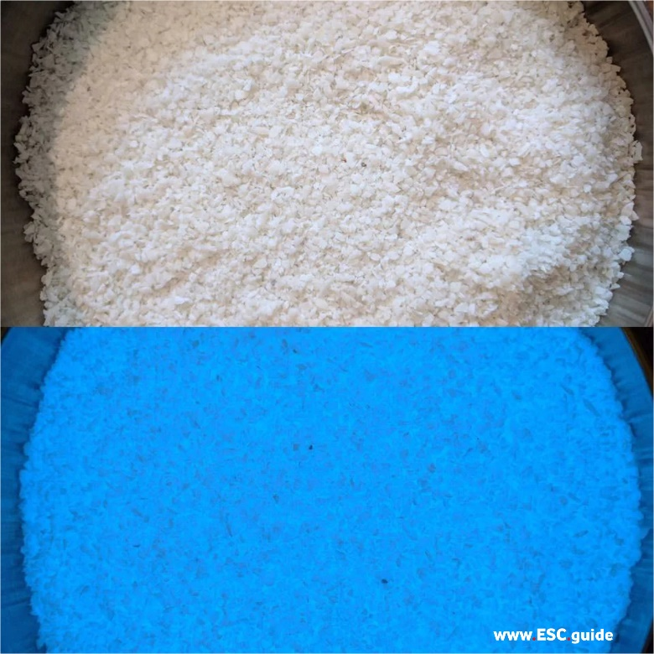

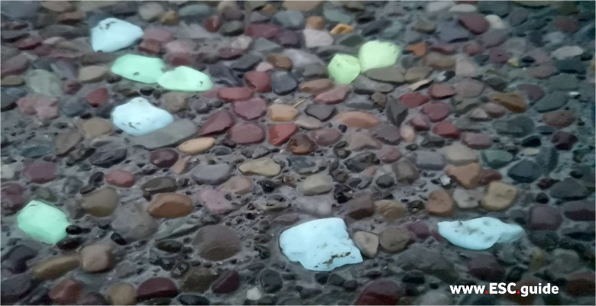 | 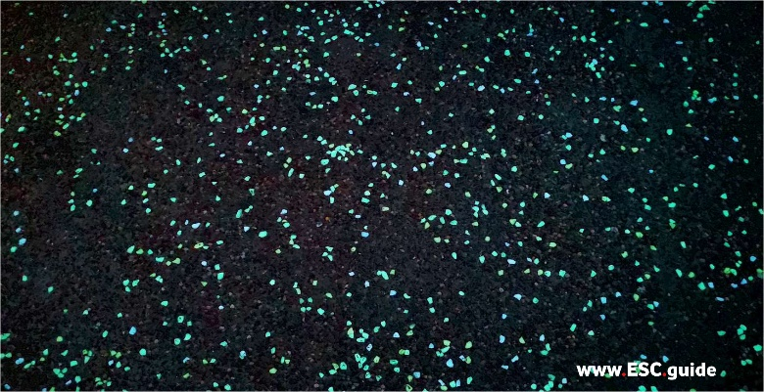
C. PROJECT GUIDE
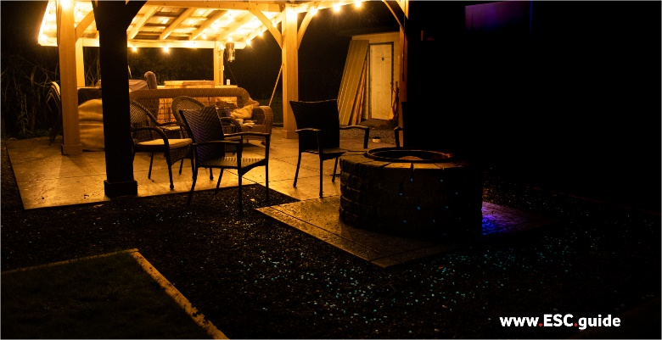 | 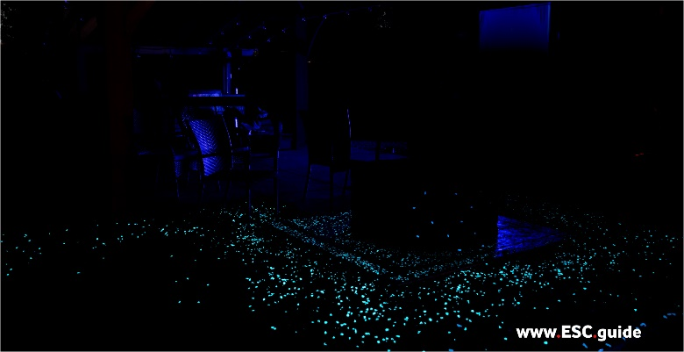
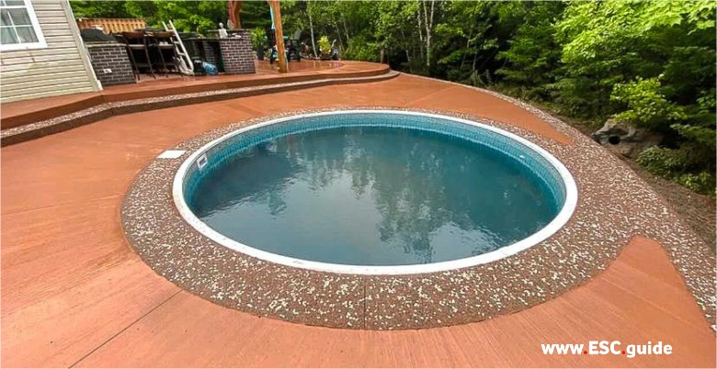 | 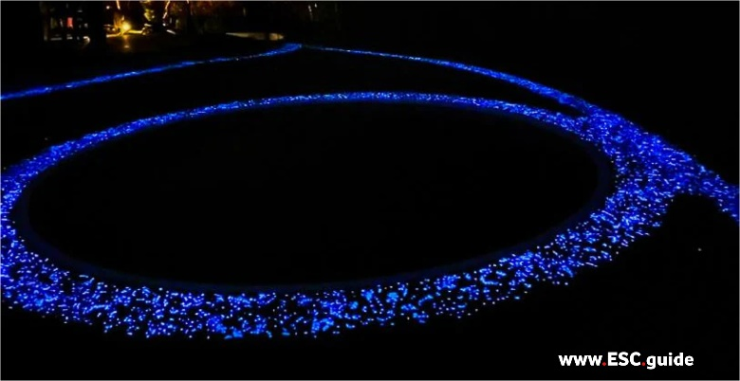
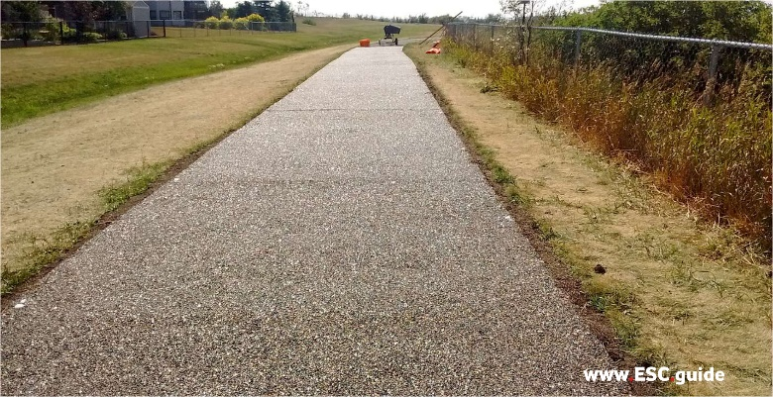 | 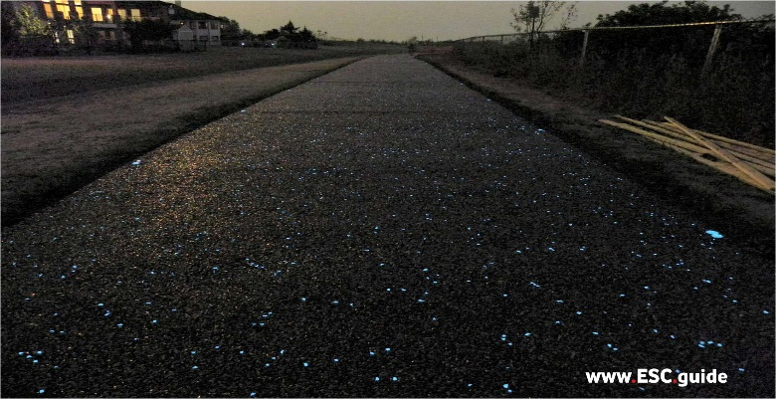

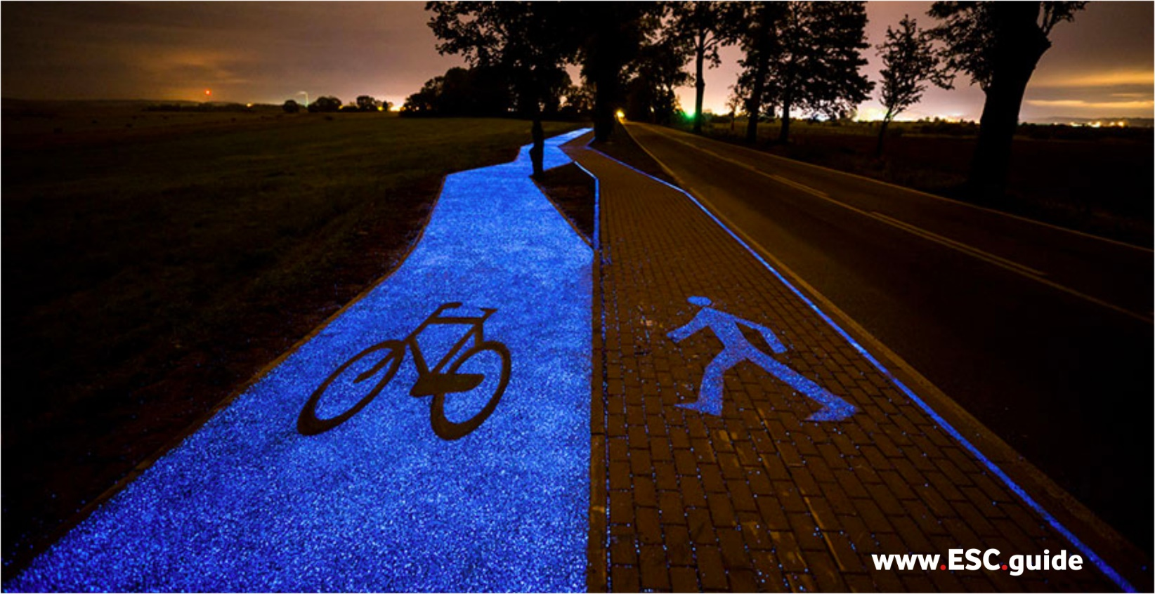

C.1) Instructables:

C.1.1. Project Guide - Read through our comprehensive Core Glow project guide for a step-by-step approach to take your design plan from idea to reality. This guide filled with information you will need for your ultimate design plan.

C.1.2. Powder Instructions - Required reading for anyone using Core Glow Powder. Read through for project tips, recipes, and safety information.

C.1.3. Luminosity Through Time (Glow Cycle)

C.2) Infographics:

C.2.4. Chemistry of Glow - Want to know how Core Glow works? Browse through our Chemistry of Glow infographic for all the chemistry specs you'll need. Available in English and French.

C.1.1. Project Guide:
Follow these step-by-step instructions to create your own Core Glow project
For a permanently beautiful surface that glows in the dark use Core Glow Commercial Grade Marble (Natural Stone). This glow stone can be used as a substitute for gravel aggregate for mixed-aggregate approaches and can be spread over the top layer of concrete, asphalt, and other paved surfaces.
Note: these tips are for the application of Core Glow Commercial Grade Marble (Natural Stone). To determine the best type of concrete to use for your project contact a local contractor or concrete retailer for advice on how to choose the best surface medium for your project.
Steps:
1. Choosing your Project Area
2. Determining the Best-Suited Core Glow Product for your Project
3. How Much to Purchase?
4. Ordering Your Product
5. Pre-Installation Testing
6. Application Methods
a. loose
b. embedded
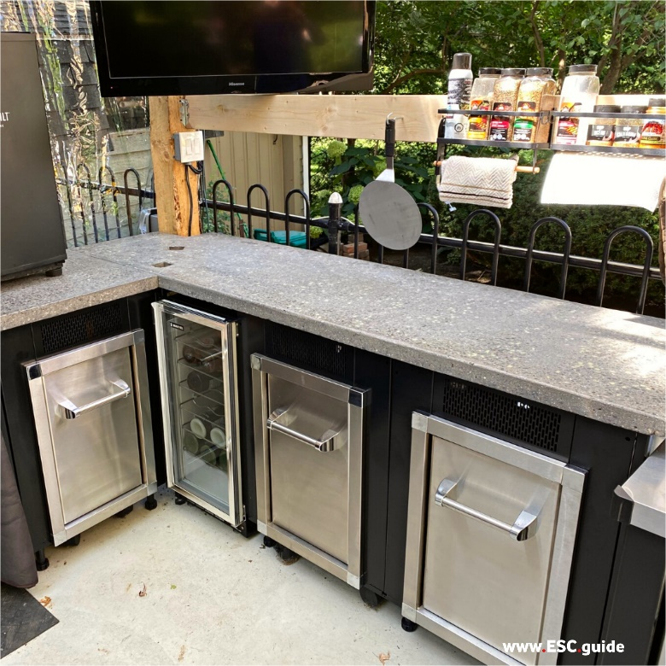 | 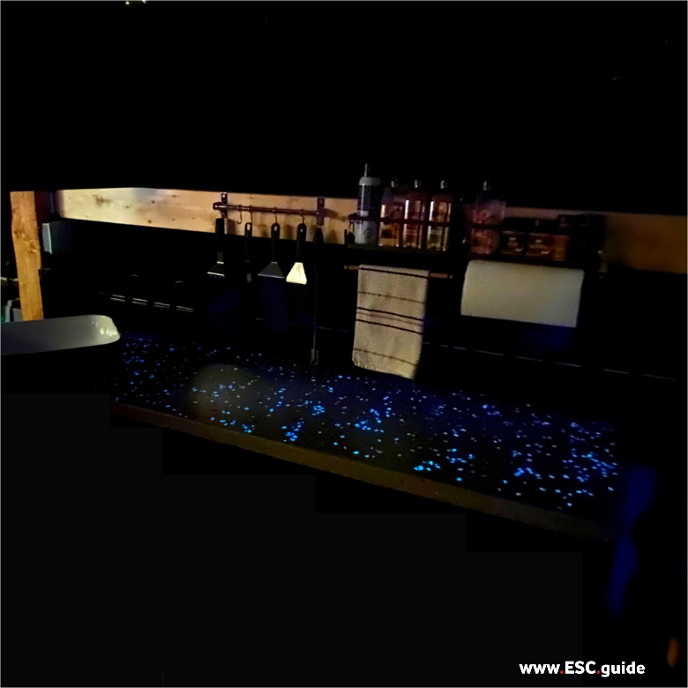

C.1.1.1. Choosing your Project Area:
Core Glow works best under certain lighting conditions. Just like a plant, Core Glow has a niche habitat where it will thrive ie. glow brightly all night long.
The optimum area outdoors is in full sunlight during the day and removed from competing light sources during the night.
The optimum area indoors is in a brightly lit room that can be turned completely dark at night (ie. window coverings installed).
Other prime locations are where you control the light conditions: anywhere indoors, customized outdoor lighting, events, public centres, etc.
Table 1. Effects of different outdoor lighting conditions on Core Glow:
Light Source | Core Glow Result | Tips to optimize glow
Full Sunlight | Optimum bright glow long charge | Great choice. View on nights with a new moon or fresh cloud cover and minimize competing light sources.
Partial Sunlight | High medium glow long charge | Place Core Glow in an area that gets sunlight late in the day for a bright glow in the evening, plus extended nighttime charge.
Low Sunlight | Medium soft glow long charge | Ensure there is little to no competing light at night so you can enjoy the soft glow of your project area.
No Sunlight | Low soft glow reduced charge | Core Glow will charge even in ambient light. To maximize this choose an area with plenty of natural light or consider altering your project location to ensure your glow stones will charge.

Table 2. Effects of competing light sources on Core Glow (for outdoor projects):
Note that competing light diminishes your ability to see Core Glow, not the light output of the Core Glow stone. For indoor projectsyou will be able to control the amount of light Core Glow receives as well as the competing light sources to achieve the best glow.
Competing light level | Example | Core Glow Result | Tips to optimize glow
None | Parks, pathways, remote and rural locations, backyards, streets with no streetlights, indoors, rarely lit locations. | Optimum  bright glow  high visibility | Place glow in areas with full sunlight to ensure a bright glow and full charge.
Low | In town, neighborhoods, between streetlights, occasionally lit locations. | High  bright glow  medium visibility | Ensure glow gets a full charge and is preferentially placed away from bright areas.
Medium | Lit pathways, streets with streetlights, lit parking lots, often lit locations. | Medium  medium glow  medium visibility | Place Core Glow in areas that need a little brightening up at night such as alleyways, surprise pathways, and corridors leading passersby to a new adventure.
High | City centres, constantly lit locations. | Low  medium glow  low visibility | Use Core Glow to light up dark areas, shady corners, surprise nooks and hideaways in city centres. Even better if surrounded by little patches of nature for urban oases.
Table 3. Effects of indoor lighting on Core Glow (for indoor projects):
Light Source | Example | Core Glow Result | Tips to optimize glow
Broad Spectrum, directly lit | Incandescent, fluorescent, CFL. | Optimum  bright glow  long charge | Aim your lights directly at the glow surface for ~10 minutes before turning them off for a super bright glow. Removecompeting light sources for the full effect.
Broad Spectrum, ambient light | Incandescent, fluorescent, CFL, blacklights. | High  medium glow  long charge | Leave lights on for 30+ minutes for a brighter immediate glow and long charge.
Filtered spectrum, ambient light | Coloured incandescent bulbs, LED, lasers. | Varied  soft glow  long charge | Filtered incandescent lights and lasers do not compete with Core Glow stones, but also do little to charge them. We suggest charging them with broad spectrum lights then turning on your colored lights. Direct lights away from glow surface for a multi-colored light and glow display.
UV Lights** | UV flashlight, UV keychain light, UV bulbs (note: requires safety gear) | Special**  Supercharged glow  Short charge | UV lights are a special case. Use a handheld light to supercharge Core Glow instantly. The UV light gives an immediate bright glow, but you will need to hold light on Core Glow for 10+ minutes for a long lasting glow.
If you have a project in mind but are concerned about the light conditions please let us know and we will go over your project with you to ensure your Core Glow application results in a bright glow that lasts all night.
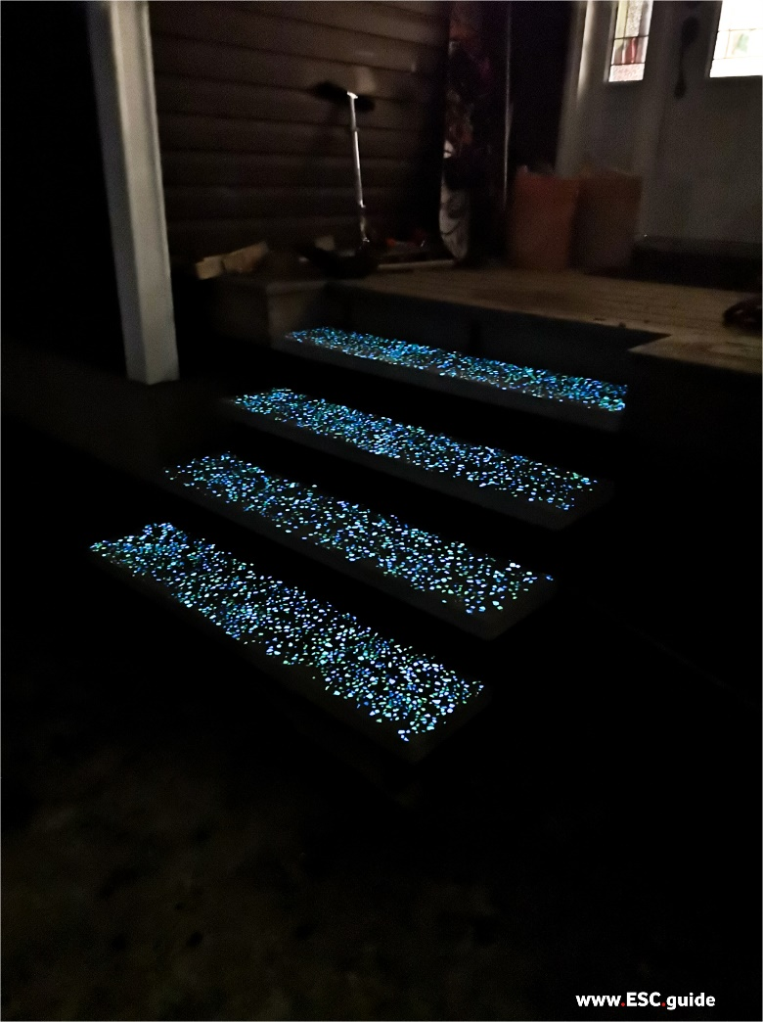 | 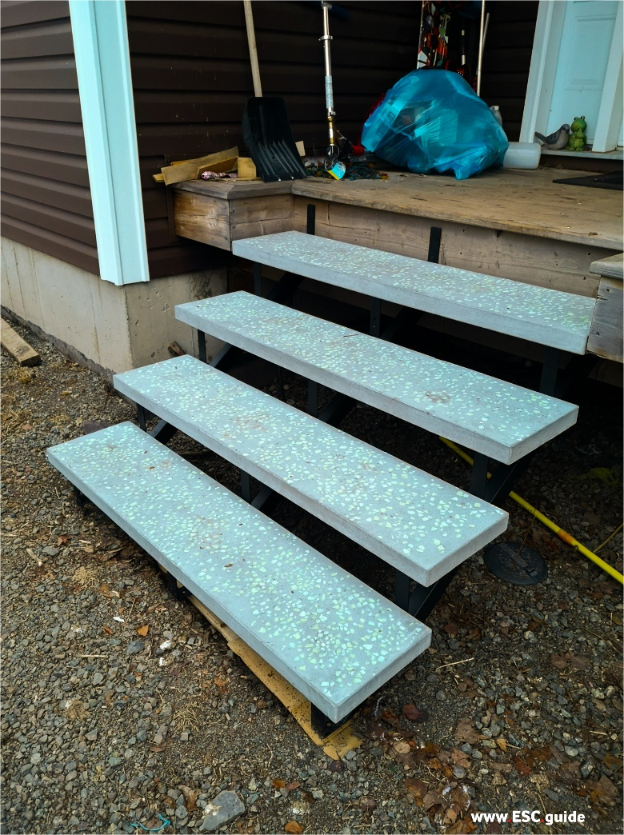

C.1.1.2. Determine the best-suited product type:
Core Glow Commercial Grade Marble (Natural Stone) comes in two sizes: 3-8mm and 8-15mm, and three colors: green,
aqua, and blue. Green is suited for safety and road markings as it is the brightest glow available. Aqua is energetic and
lively. Blue is mellow and ethereal. Choose one color or a mix based on your aesthetic preferences and the desired mood for your project space. We love seeing blue used in spas, secret walkways, and oasis-like bathrooms. Aqua is great for bar countertops, dancefloors, and kitchens. Green is a hit wherever- great for outdoor adventure areas, arena entryways, and public spaces.
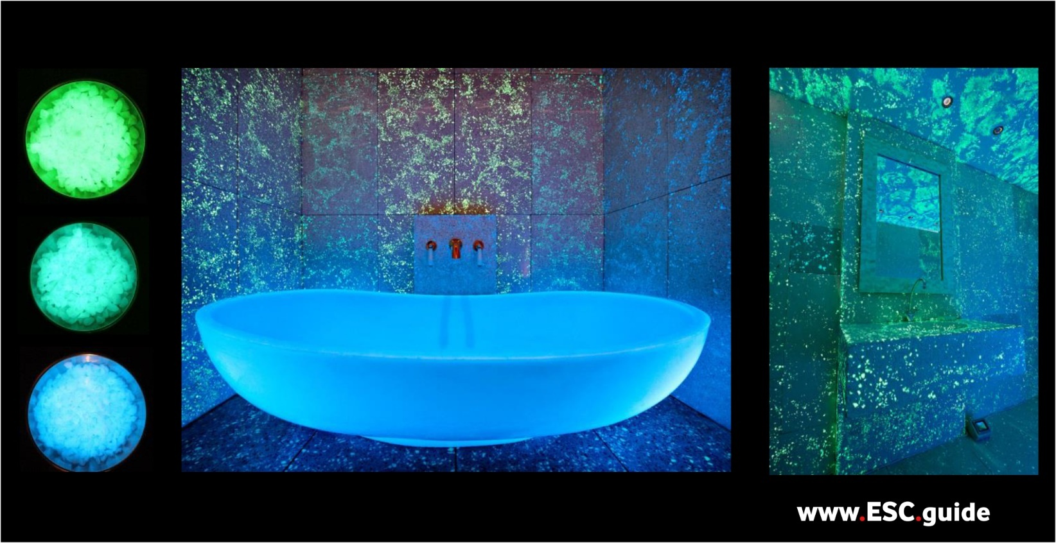
Top left: Green Core Glow Commercial Grade Marble, Mid Left: Aqua Core Glow Commercial Grade Marble, Bottom Left: Blue Core Glow Commercial Grade Marble, Mid: Mellow and sensual glow with blue and aqua glow. Far Right: energetic nightlife mood with aqua and green glow.

C.1.1.3. How much to purchase?
Our basic guideline is 1lb per 16 ft2 for high density dispersed.
Formula: | (project area in square feet) | = x lbs of Core Glow Commercial Grade Marble (Natural Stone)
 | 16 square feet
Tweak the denominator up for estimates based on lower density coverage, or down for higher density estimates.

C.1.1.4. Ordering your Chosen Product:
We offer heavily discounted bulk pricing for 4lb bags. Simply click on your chosen product type and select the 4lb option before proceeding to checkout. If you require 100+ pounds for your project please get in touch with us for volume pricing information. Shipping is usually between 5-11 days from date of purchase. For large orders requiring factory-direct service shipping is 3-7 weeks.
C.1.1.5. Pre – Installation Testing
We highly recommend starting with a small mock up using your chosen medium before using Core Glow. This will enable you to practice your scattering method, try out a few different coverage densities, and test how long to let your medium set before spreading Core Glow across (if embedding permanently into surface). This is what the Core Glow Commercial Sample Pack is intended for. Practice with the selection of Core Glow Commercial Grade Marble (Natural Stone) in the Commercial Sample Pack, try different colors and size combinations, and decide what you like best for your project. You can also order 1lb or 4lb bags of each color if you would like more for your project mock-up.
Pro Tip: use a handheld lime spreader or similar instrument to achieve a uniform spread. Make sure to choose one which will accommodate an aggregate size of up to 15mm.
Measurements to take during pre test (for concrete applications):
1. Time (in minutes) to allow concrete to set pre- application of Core Glow.
You need your concrete to be set enough to allow the Core Glow Commercial Grade Marble (Natural Stone) to be pushed into the surface without sinking down. Depending on your chosen medium this time will vary. With pre-testing we recommend placing a few stones every 20 minutes until it is clear the stones will not sink.
C.1.1.6. Final Installation Steps
There are many ways to incorporate Core Glow into your project. Simple scattering, topdressings, and edging with loose stones is a simple way to add a touch of Core Glow. For permanent applications you can using a bonding resin, top-dress a cement surface, mix with aggregate for an exposed-aggregate floor, and more. We have compiled some tips below for applying Core Glow.
a) Simple scatter (topdress method):
Simply toss Core Glow Commercial Grade Marble (Natural Stones) across you project area for a quick, easy, and gorgeous galaxy or deep-sea like surface.
- Pros: fast application time, changeable, broad coverage
- Cons: impermanent, Core Glow can be lost over time
- Tips: - Use a Core Path or Core Drive stabilizing system to prevent your Core Glow from sinking beneath your gravel surface. For commercial and public project using this method we recommend using a resin-bond to lock the glow stones in place.
- Use a handheld lime spreader to achieve an even spread of your Core Glow stones.
b) Edging:
Group Core Glow stones together to edge a path or create your own pathway in the dark. Useful for night illumination of walking areas.
- Pros: bright and noticeable glow, conserves Core Glow stones if project area is very large
- Cons: no galaxy-effect
- Tips: cut hole in bottom of bag (like whipped cream) to slowly pour stones along edging area
c) Embed in Concrete Surface:
Ensure you have your product in the correct quantity, have practiced your application method, and have the time required to wait before applying Core Glow to your surface area (we recommend determining this time in pretesting). If your project area is very large and the window of time needed to apply the Core Glow is over an hour we suggest pouring the concrete in sections, or at a minimum keeping track of which areas were poured first to ensure your application goes smoothly. Ensure that you have proper training for the concrete installation, or are using an experienced contractor. We cannot stress enough the importance of proper site preparation!
Materials:
- Core Glow Commercial Grade Marble (Natural Stone)
- Medium of choice (concrete, ashphalt, etc.) along with supplier recommended gear and tools
- Safety gear and tools (gloves, spreader, etc.)
- Timer
- Handheld lime spreader (optional)
Step by step Installation Process for Top-Dress Approach
- Pour concrete mixture
- Allow for required setting time before applying Core Glow (determined in pre-installation testing process)
- Spread the Core Glow Commercial Grade Marble (Natural Stones) across the project surface. Use a tamp or spreader to push the aggregate into the surface, ensuring a level surface area. For large projects a roller compacter is recommended (handheld or industrial sized).
- Let the concrete set for required time as set by manufacturer
- Use a power sander to buff down any uneven sections or stones that have become covered with concrete.
- Complete project with concrete cure or surface treatment as required by manufacturer.

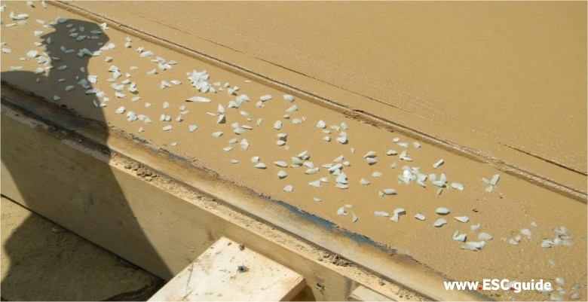 | 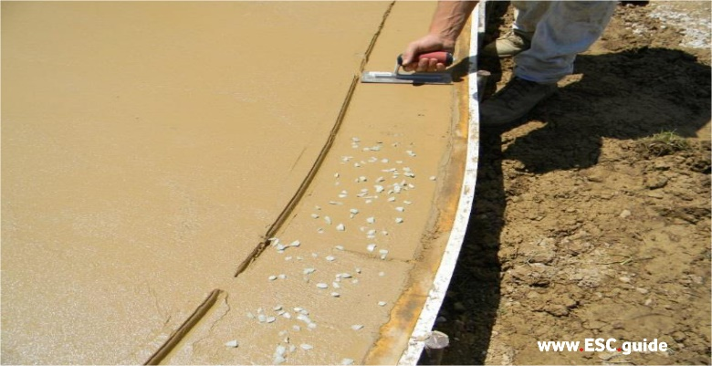
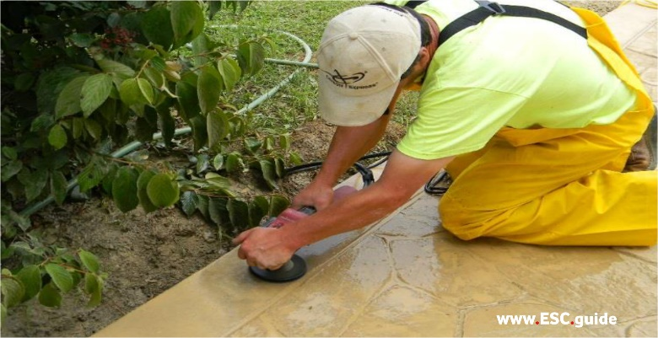 | 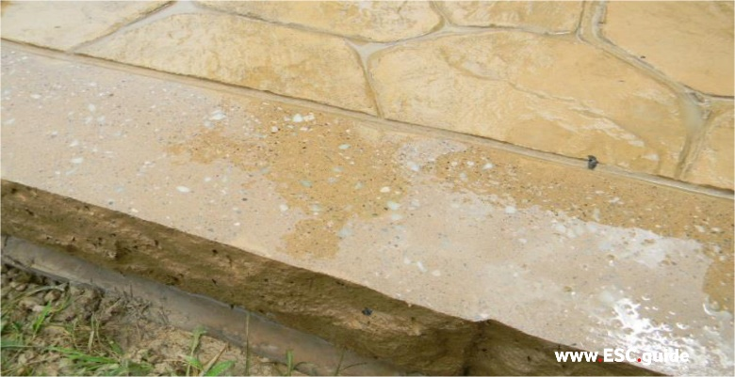

Top Left: Place Core Glow Commercial Grade Marble (Natural Stones) along project surface area once allotted time has passed.
Surface should be stiff but not hard. Top Right: Press stones into the cement surface. Bottom Left: Sand down surface area once cement has set. Bottom Right: Finished concrete surface with glow stones embedded permanently in the surface.
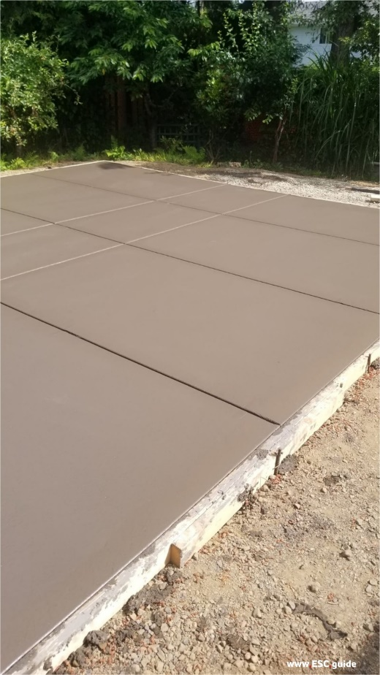 | 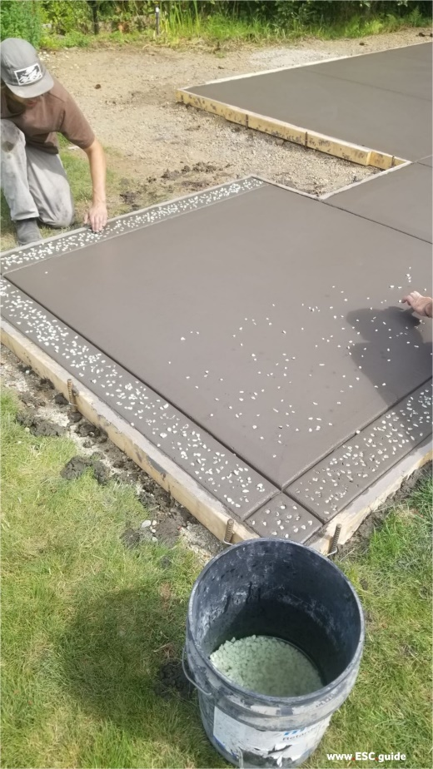 | 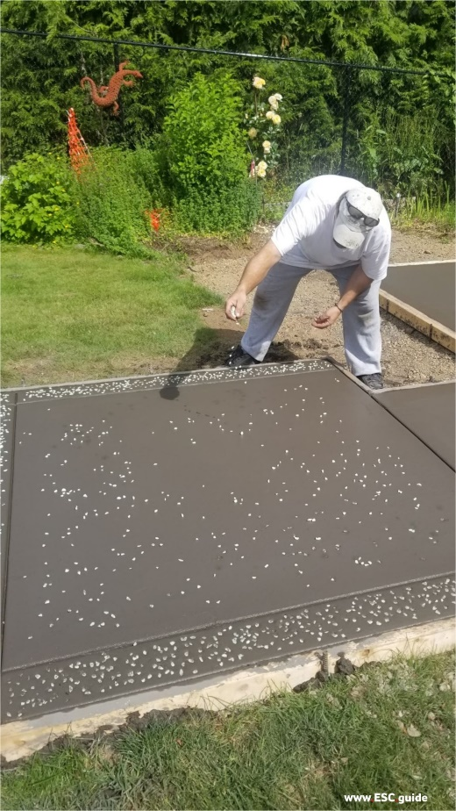

C.1.2. Powder Instructions
Instructions for Using Core Glow Powder
Applications:
Mix Core Glow powder with clear resins, epoxies, paints, and lacquers to create your own glow designs. You can mix the powder directly into the medium or dust it over top.
Table 1. Suggested mixtures for maximum glow
Medium | Glow Powder
1 oz (30 ml) | ½ oz (14gm)
1 pint (473 ml) | ½ lb (225 gm)
1 quart (950 ml) | 1 lb (500 gm)
1 gallon (3.8 L) | 2 lb (900 gm)

Core Glow powder is composed of 100% strontium aluminate crystals. Choose your medium carefully to avoid the decomposition of the crystal structure.
- Oil and alcohol based mediums will suspend the glow crystals without breaking them down.
- Water based mediums such as acrylic or gel will break down the strontium aluminate crystal structure reducing the luminosity and longevity of your project.

Photos (clockwise from top left): (1) Core glow powder is slightly off-white in regular light. (2) Green glow powder glows the brightest at 520nm. (3) Aqua glow powder at 480nm. (4) Blue glow powder at 400nm.

Project Steps:
- Choose your favourite glow colour and approproate medium to combine.
- Prepare the surface. Choose a primer specific to the substrate to be painted, we suggest using a white or light coloured primer.
- Mix the glow powder thoroughly with your chosen medium. Only mix as much as you immediately plan on using. Mix gently to avoid crushing the strontium aluminate crystals.
- Apply multiple thin coats to your project surface, allowing each application to dry fully between coats. Apply additional coats to increase luminosity.
- Finish your project with a clear sealant.
- Allow surface to charge in the sun or by overhead light.

Project Tips:
- Add 10-50% concentration of pigment by weight to medium to achieve visible glow.
- Use clear non-water based paint. Pigments will shield and decrease the intensity of the glow and water will compromise the structure of the glow crystals.
- When mixing add medium slowly to powder to control the concentration.
- Choose a medium with high viscosity. Mediums with high viscosity hold the glow powder in suspension superiorly compared to thin mediums.
- Paint the undersurface white to facilitate the highest glow.
- Add additional layers to increase intensity of the glow.

Caution: Although our products are non-toxic, they will cause irritation if inhaled. We recommend wearing a dust mask and safety glasses when pouring and handling Core Glow powder and consulting the MSDS sheet.

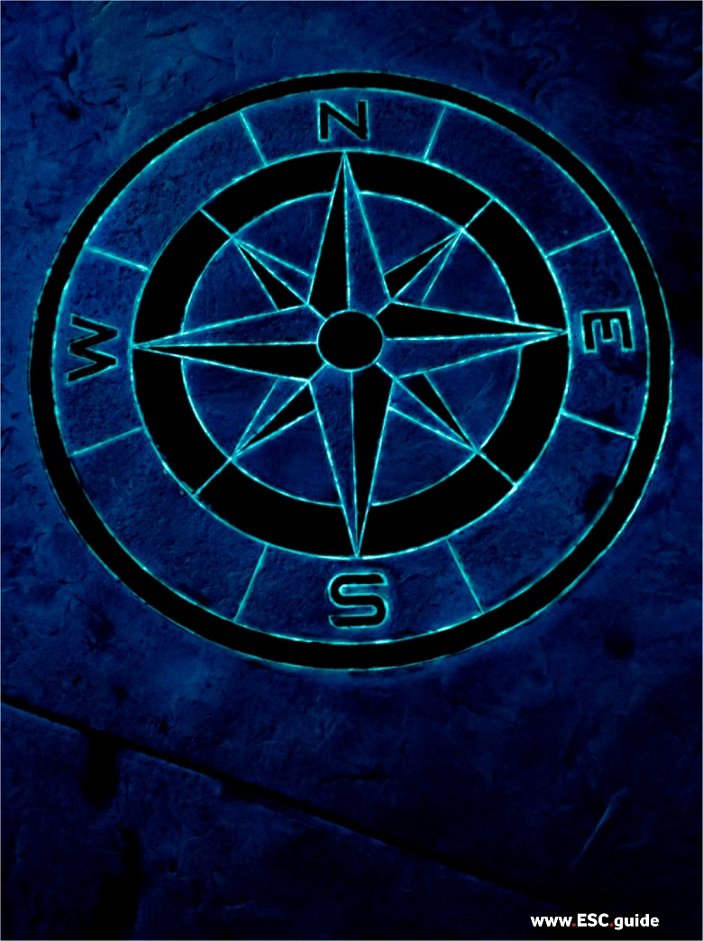 | 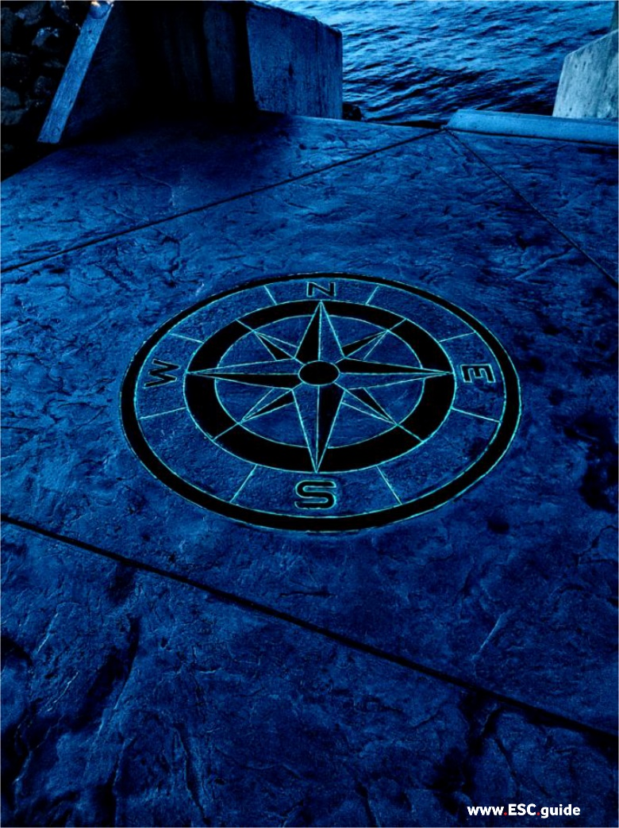

C.1.3. Luminosity Through Time (Glow Cycle)
Fig.1. Core Glow Crystalline Strontium Aluminate SrAl2O4:Eu2+ luminosity curve over time. Glow intensity isbrightest at initial charge and is observed to follow the following: initial high intensity glow lasts approx 30minutes, dropping to medium intensity glow by 120 minutes, medium intensity glow by 240 minutes, and ambient glow from 240 minutes onwards.
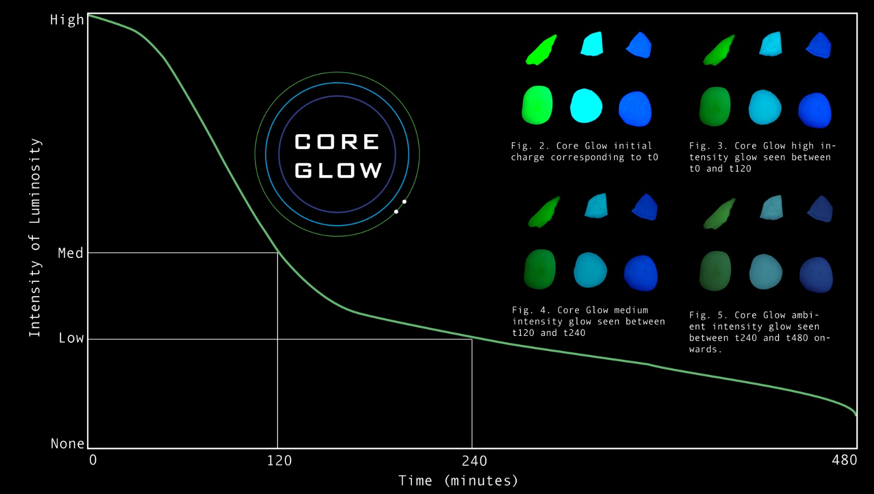

C.2.4. Chemistry of Glow
Crystalline Strontium Aluminate SrAl₂O₄:Eu²⁺
Glow in the dark materials are phosphorescent and always contain a ‘phosphor’. There is a quick light absorption and slow light emission which results in the glow in the dark phenomena. Strontium Aluminate: solid powder, nonflammable, pale yellow, monoclinic crystalline, non-radioactive, chemically and biologically inert^{[2][4]}. Strontium aluminate is 10x brighter and has a 10x longer glow than its dimmer predecessor, copper-activated zinc sulfide.

Chemical Formula: SrAl₂O4:Eu2+
Advanced glow technologies use strontium aluminate doped with europium to activate the phosphorescent properties of strontium aluminate. The europium interacts via covalent interactions with the oxygen atoms and crystal field splitting of the 5d orbital^{[2]} .
Q. What is doping?
A. Purposely mixing in an impurity to activate desired properties.
Q. What is europium?
A. Europium is a reactive rare earth metal which readily oxidizes in air and water. It is commonly used in fluorescent lights and CRT TV displays.
Q. Is strontium aluminate doped with europium toxic?
A. Strontium aluminate doped with europium is non toxic. Strontium aluminate phosphors are harmless as defined by the Laws of Chemical Substances. Our product specifically was deigned harmless under the OSHA (Occupational Safety and Health Administration) Hazard Communication Standard 29 CFR 1900.1200^{[4]} .
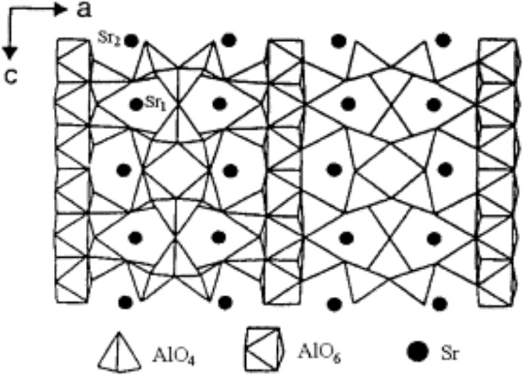
Fig. 1. 2D crystal structure of strontium aluminate.

Reactivity Data:
Stability: | stable
Hazardous Polymerization: | will not occur
Conditions to Avoid: | contact with acids
Incompatibility: | contact with acids
Hazardous Decomposition Products: | will not occur^{[4]}
Colours: | Three colours are available. The colour emission changes with the number of oxygen atoms, which directly affects the internal crystal structure of the final material.
Blue: | 400nm: SrAl₂O₁₉
Aqua: | 480nm: SrAl₂O₇
Green: | 520nm: SrAl₂O₄
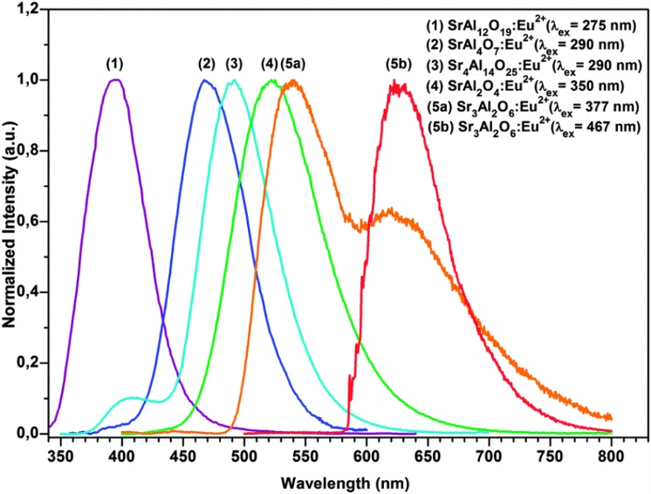
Fig. 2. Emission spectrum of various strontium aluminates. 2, 3, and 4 are available commercially.
Industrial applications: Strontium aluminates are being studied as a proposed material to immobilize fission products of radioactive waste[3], to increase the efficiency of solar panels[1], and provide electricity-free illumination for road surface markings.
References:
[1] Hengchao, Sun, et. al. "Long Afterglow SrAl2O4: Eu,Dy Phosphors for CdS Quantum Dot-sensitized Solar Cells with Enhanced Photovoltaic Performance." Journal of Materials Chemistry 21 (2013): 6388-392. Web. 14 June 2016.
[2] Katsumata, Tooru, et. al. "Characterization of Strontium Aluminate Crystals Used for Long Duration Phosphors." Journal of the American Ceramic Society 81.2 (1998): 413-16. Web. 14 June 2016.
[3] Kong, Peter C. "Ceramic Hosts for Fission Product Immobilization." US Department of Energy (2010). Idaho National Laboratory. Web. 14 June 2016.
[4] Product: Core Glow Glass. Material and Safety Data Sheet. Core Systems. Web. June 2012

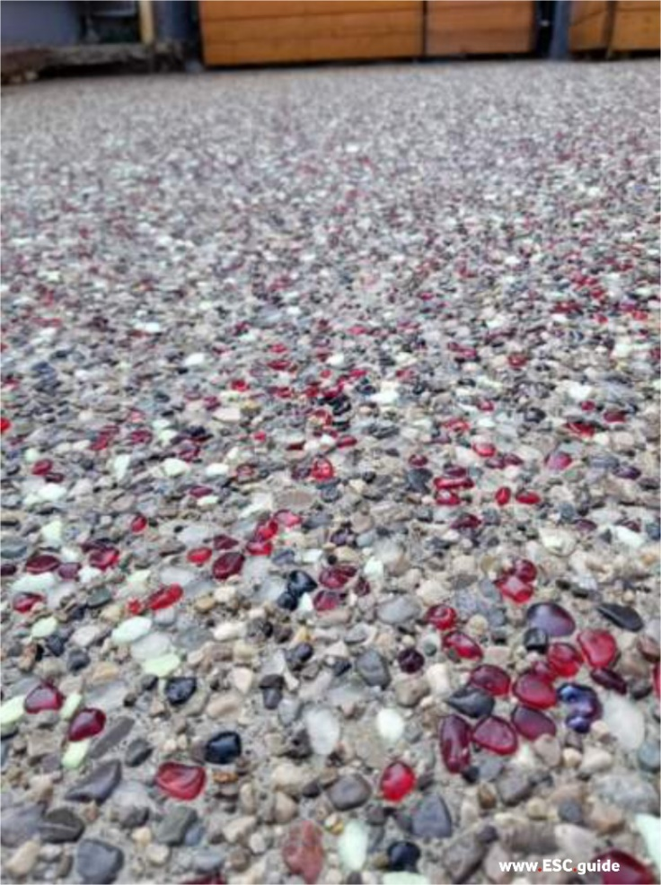 | 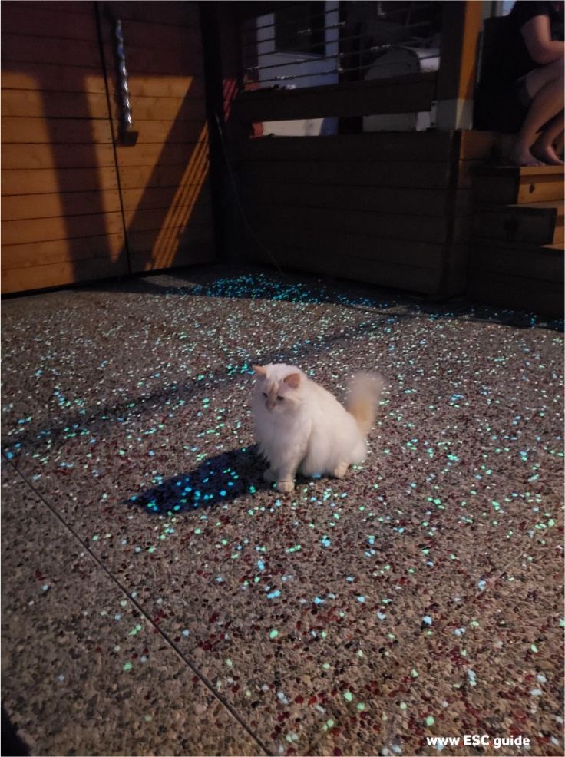
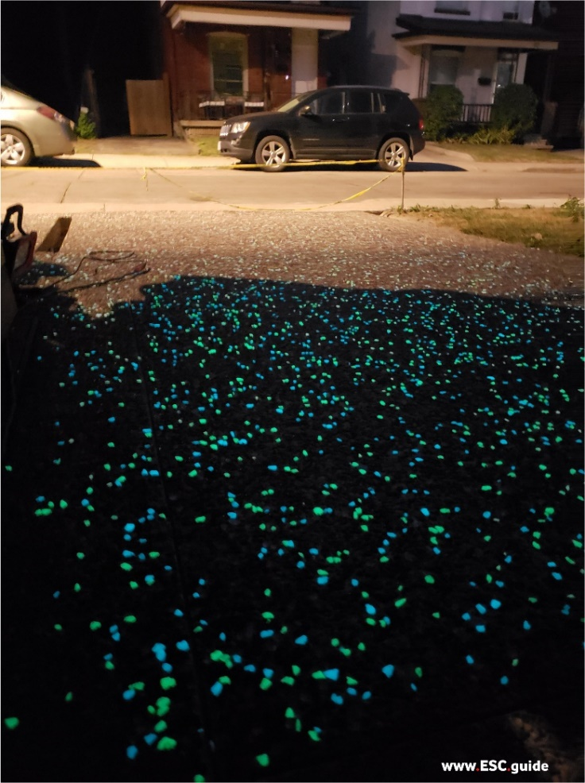 | 